**Lab 3**

Diana Elizabeth Torres López

TriOS College / Sault College

CSD214 Programming Concepts 2

Sarmad Mohammad

Friday, March 7th, 2025

**Lab 3**

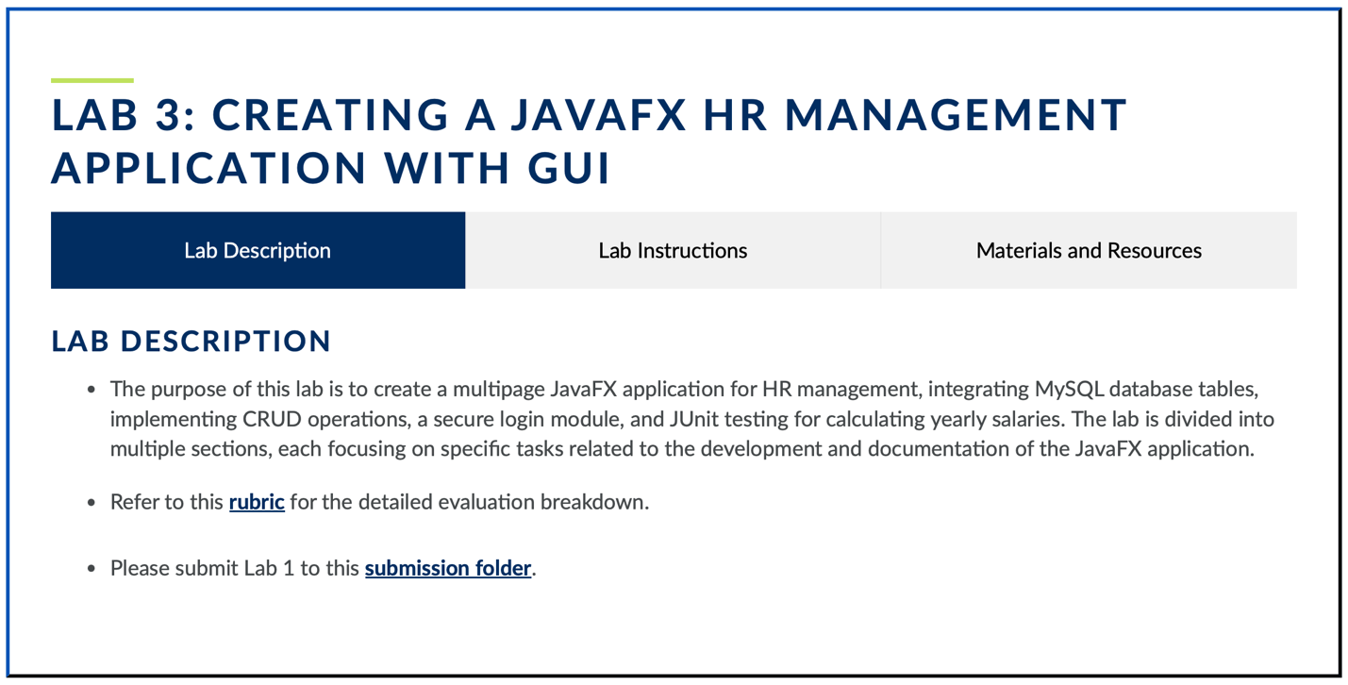

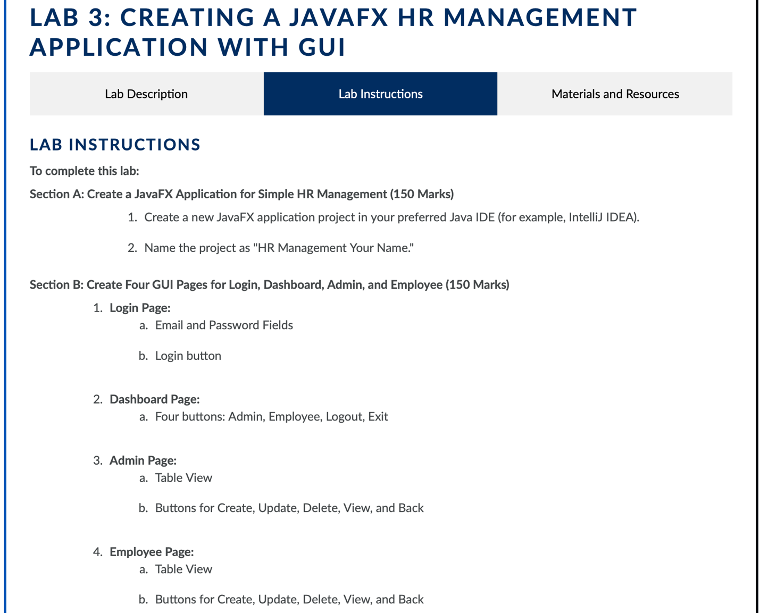

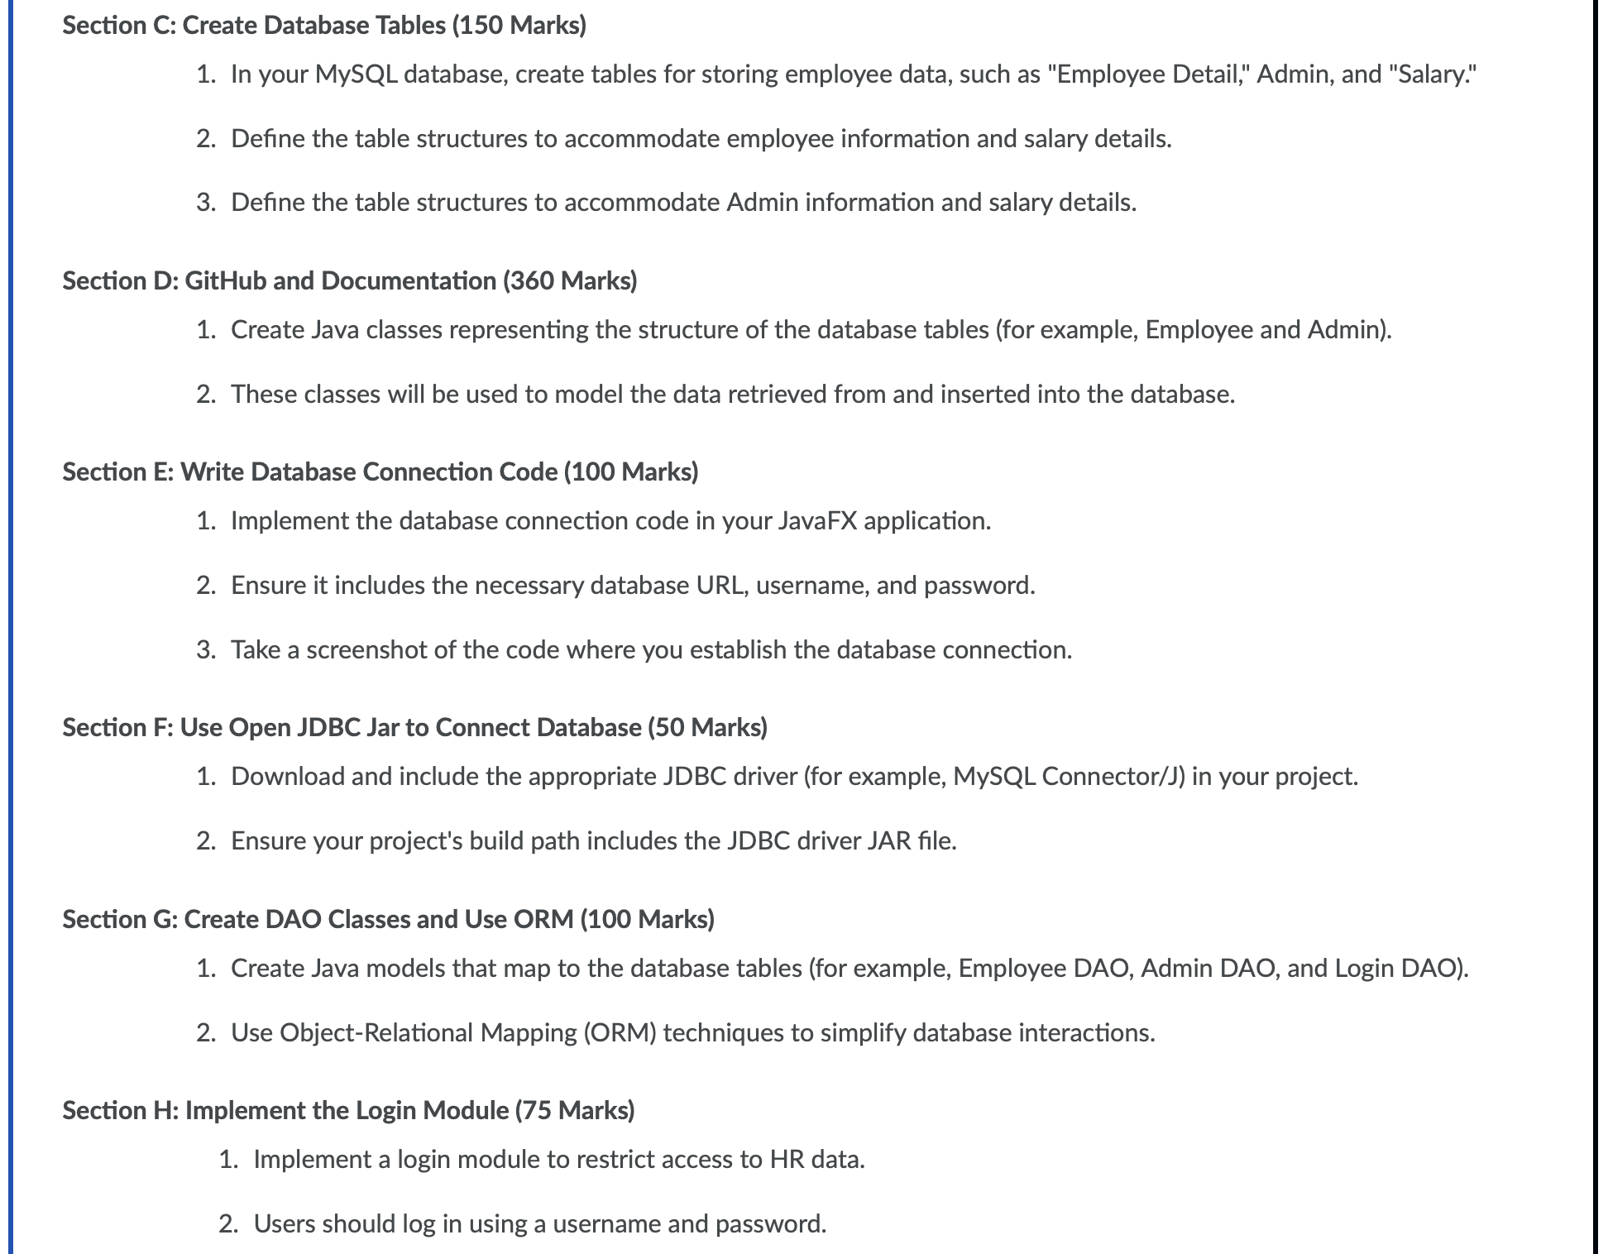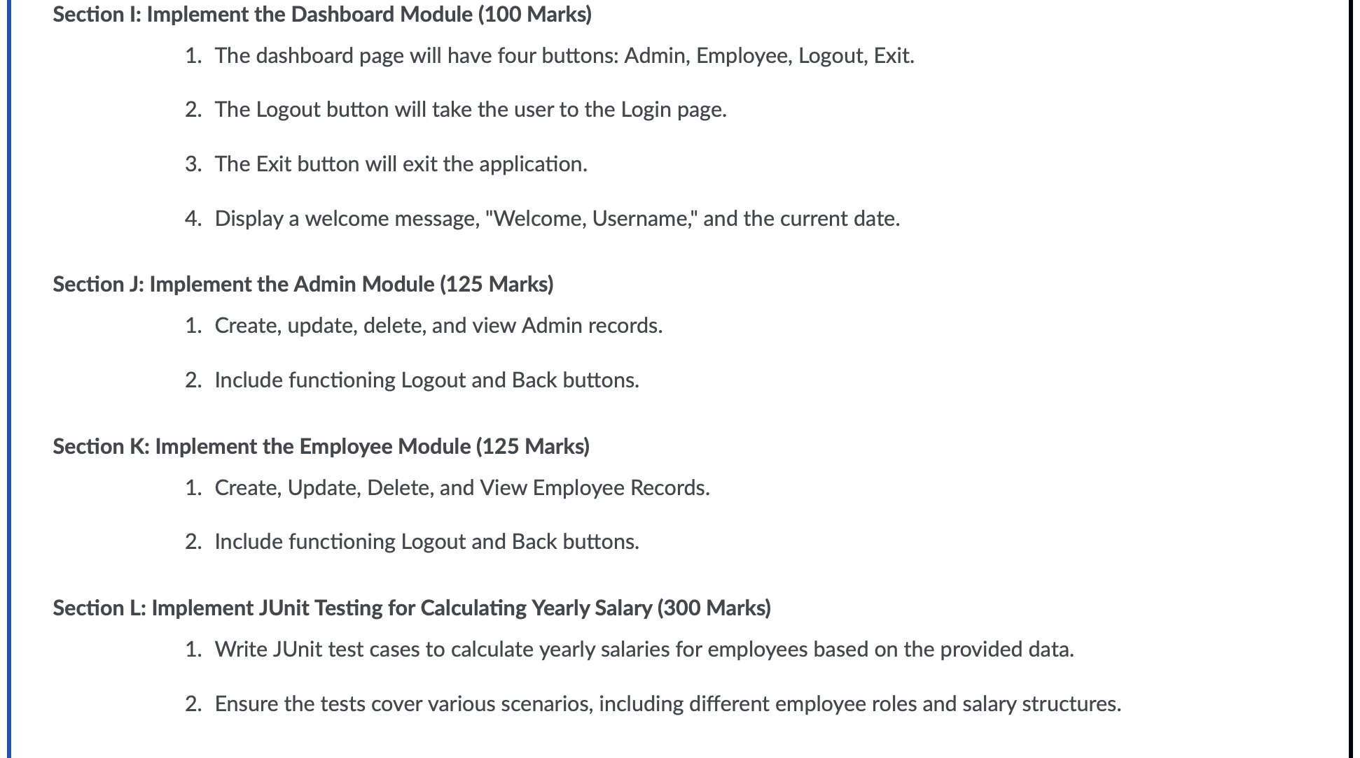

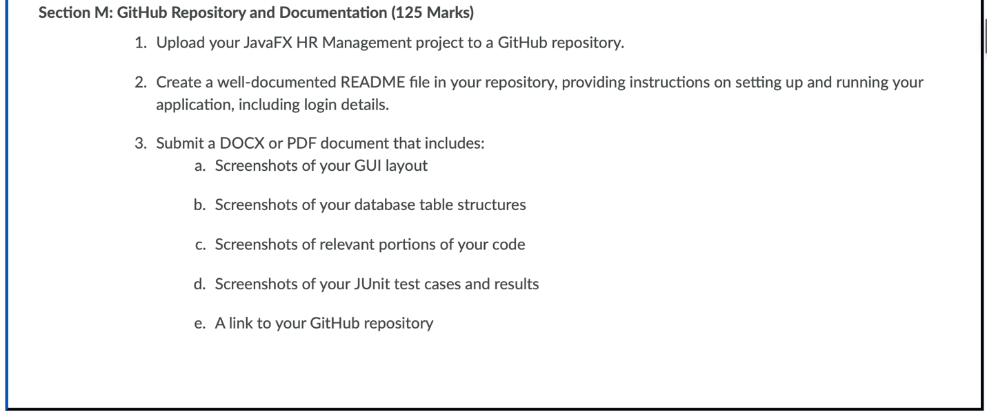

LAB INSTRUCTIONS

To complete this lab:

Section A: Create a JavaFX Application for Simple HR Management (150 Marks)

1. Create a new JavaFX application project in your preferred Java IDE (for example, IntelliJ IDEA).
2. Name the project as "HR Management Your Name."

Section B: Create Four GUI Pages for Login, Dashboard, Admin, and Employee (150 Marks)

1. Login Page:
2. Email and Password Fields
3. Login button
4. Dashboard Page:
5. Four buttons: Admin, Employee, Logout, Exit
6. Admin Page:
7. Table View
8. Buttons for Create, Update, Delete, View, and Back
9. Employee Page:
10. Table View
11. Buttons for Create, Update, Delete, View, and Back

Section C: Create Database Tables (150 Marks)

1. In your MySQL database, create tables for storing employee data, such as "Employee Detail," Admin, and "Salary."
2. Define the table structures to accommodate employee information and salary details.
3. Define the table structures to accommodate Admin information and salary details.

Section D: GitHub and Documentation (360 Marks)

1. Create Java classes representing the structure of the database tables (for example, Employee and Admin).
2. These classes will be used to model the data retrieved from and inserted into the database.

Section E: Write Database Connection Code (100 Marks)

1. Implement the database connection code in your JavaFX application.
2. Ensure it includes the necessary database URL, username, and password.
3. Take a screenshot of the code where you establish the database connection.

Section F: Use Open JDBC Jar to Connect Database (50 Marks)

1. Download and include the appropriate JDBC driver (for example, MySQL Connector/J) in your project.
2. Ensure your project's build path includes the JDBC driver JAR file.

Section G: Create DAO Classes and Use ORM (100 Marks)

1. Create Java models that map to the database tables (for example, Employee DAO, Admin DAO, and Login DAO).
2. Use Object-Relational Mapping (ORM) techniques to simplify database interactions.

Section H: Implement the Login Module (75 Marks)

1. Implement a login module to restrict access to HR data.
2. Users should log in using a username and password.

Section I: Implement the Dashboard Module (100 Marks)

1. The dashboard page will have four buttons: Admin, Employee, Logout, Exit.
2. The Logout button will take the user to the Login page.
3. The Exit button will exit the application.
4. Display a welcome message, "Welcome, Username," and the current date.

Section J: Implement the Admin Module (125 Marks)

1. Create, update, delete, and view Admin records.
2. Include functioning Logout and Back buttons.

Section K: Implement the Employee Module (125 Marks)

1. Create, Update, Delete, and View Employee Records.
2. Include functioning Logout and Back buttons.

Section L: Implement JUnit Testing for Calculating Yearly Salary (300 Marks)

1. Write JUnit test cases to calculate yearly salaries for employees based on the provided data.
2. Ensure the tests cover various scenarios, including different employee roles and salary structures.

Section M: GitHub Repository and Documentation (125 Marks)

1. Upload your JavaFX HR Management project to a GitHub repository.
2. Create a well-documented README file in your repository, providing instructions on setting up and running your application, including login details.
3. Submit a DOCX or PDF document that includes:
4. Screenshots of your GUI layout
5. Screenshots of your database table structures
6. Screenshots of relevant portions of your code
7. Screenshots of your JUnit test cases and results
8. A link to your GitHub repository

The approach for this is creating a database in MySQL Workbench with the tables “Admin”, “EmployeeDetail” and “Salary”.

We create the table named “companydiana” with the tables needed.

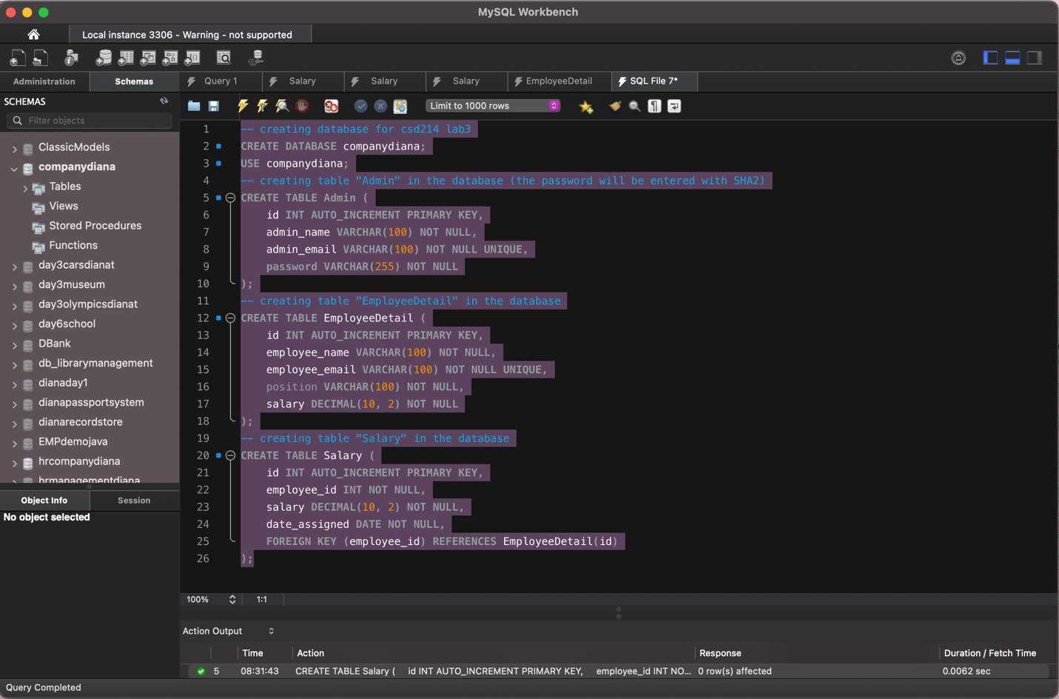

SQL code written:

-- creating the database for csd214 lab3

CREATE DATABASE companydiana;

USE companydiana;

-- creating the table "Admin" in the database (the password will be entered with SHA2)

CREATE TABLE Admin (

id INT AUTO_INCREMENT PRIMARY KEY,

admin_name VARCHAR(100) NOT NULL,

admin_email VARCHAR(100) NOT NULL UNIQUE,

password VARCHAR(255) NOT NULL

);

-- creating the table "EmployeeDetail" in the database

CREATE TABLE EmployeeDetail (

id INT AUTO_INCREMENT PRIMARY KEY,

employee_name VARCHAR(100) NOT NULL,

employee_email VARCHAR(100) NOT NULL UNIQUE,

position VARCHAR(100) NOT NULL,

salary DECIMAL(10, 2) NOT NULL

);

-- creating the table "Salary" in the database

CREATE TABLE Salary (

id INT AUTO_INCREMENT PRIMARY KEY,

employee_id INT NOT NULL,

salary DECIMAL(10, 2) NOT NULL,

date_assigned DATE NOT NULL,

FOREIGN KEY (employee_id) REFERENCES EmployeeDetail(id)

);

Then, we insert sample data into the tables

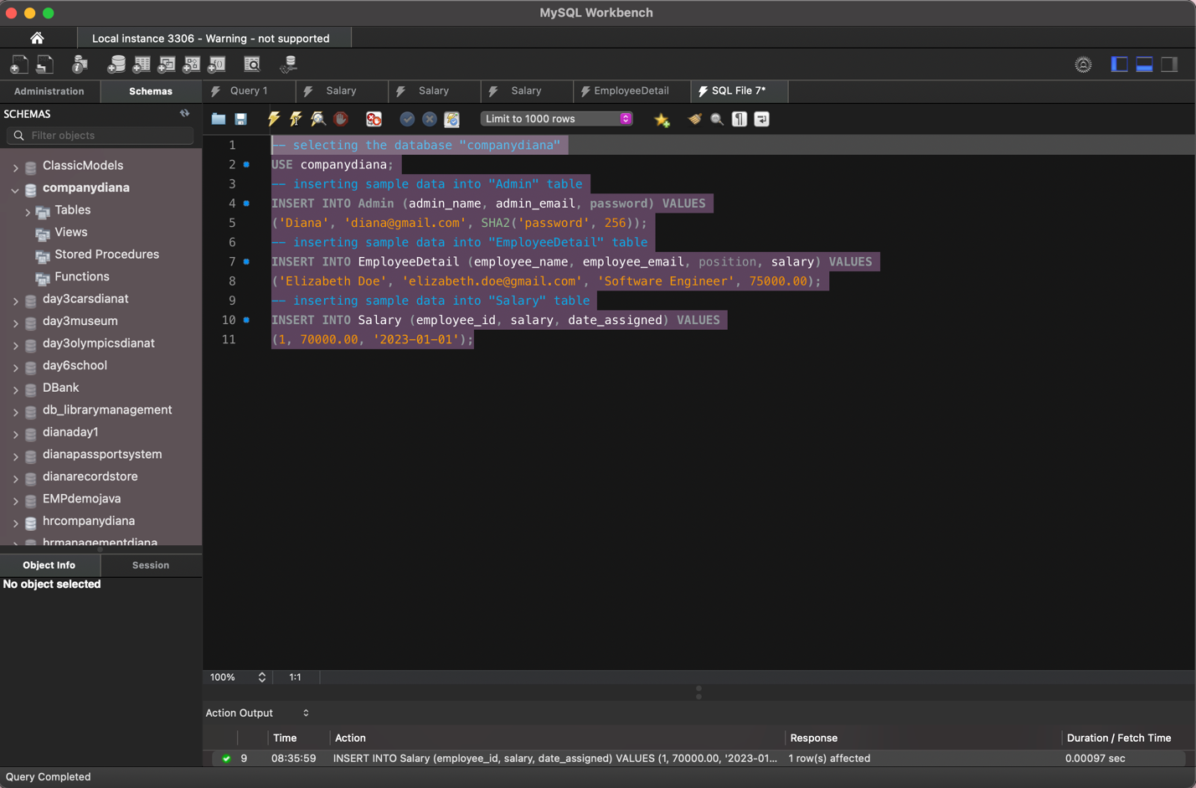

SQL Code written:  
-- selecting the database "companydiana"

USE companydiana;

-- inserting sample data into "Admin" table

INSERT INTO Admin (admin_name, admin_email, password) VALUES

('Diana', 'diana@gmail.com', SHA2( 'password', 256));

-- inserting sample data into "EmployeeDetail" table

INSERT INTO EmployeeDetail (employee_name, employee_email, position, salary) VALUES

('Elizabeth Doe','elizabeth.doe@gmail.com', 'Software Engineer', 75000.00);

-- inserting sample data into "Salary" table

INSERT INTO

Salary (employee_id, salary, date_assigned) VALUES

(1, 70000.00, '2023-01-01');

The database now is populated, and each table looks like this:

Table “Admin”:   
SELECT * FROM companydiana.Admin;

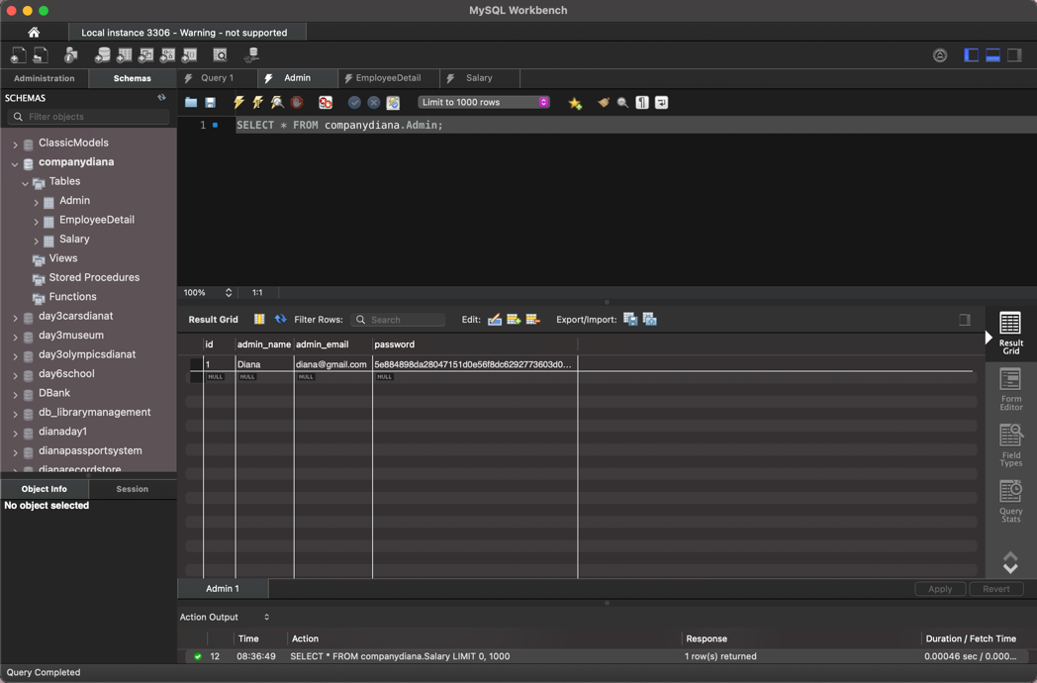

Table “EmployeeDetail”

SELECT * FROM companydiana.EmployeeDetail; 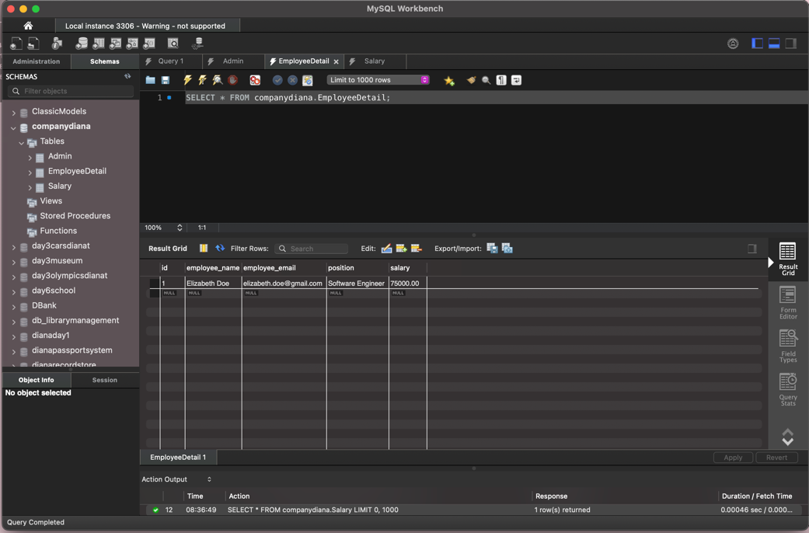

Table “Salary”

SELECT * FROM companydiana.Salary; 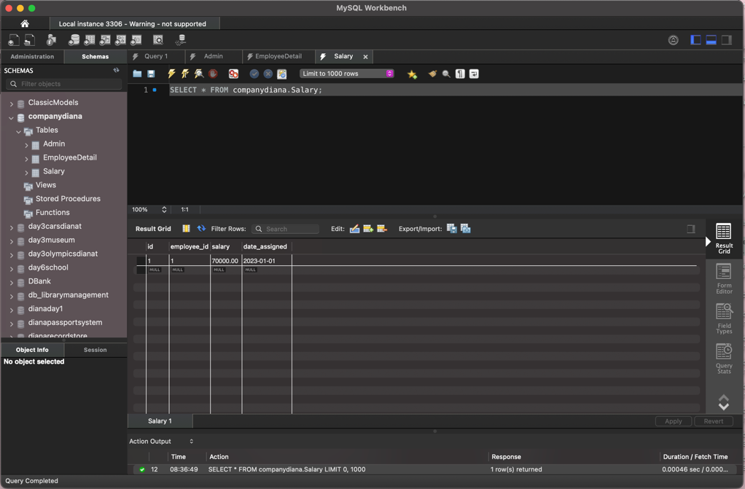

We open IntelliJ IDEA and create a JavaFX project named “HR Management Diana”. To start creating the application. 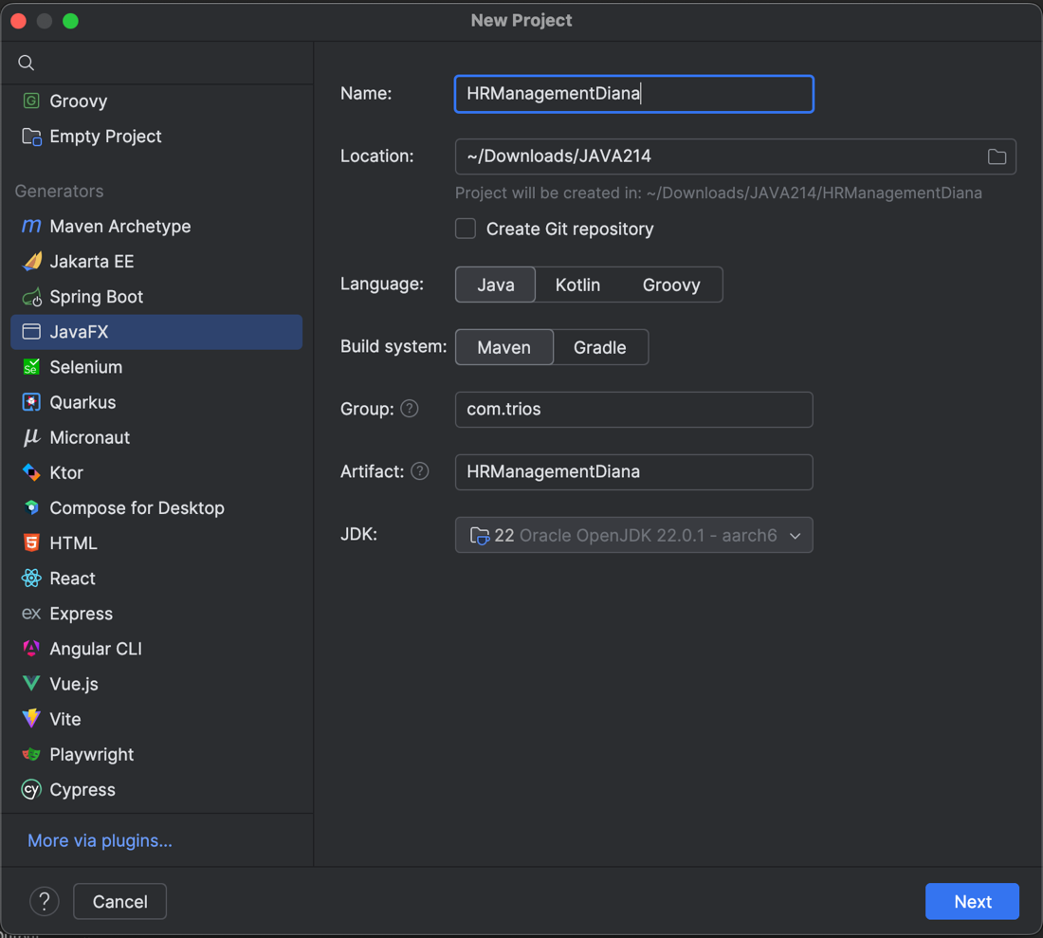

In the project, we make sure to install the JAR file of mySQL connector

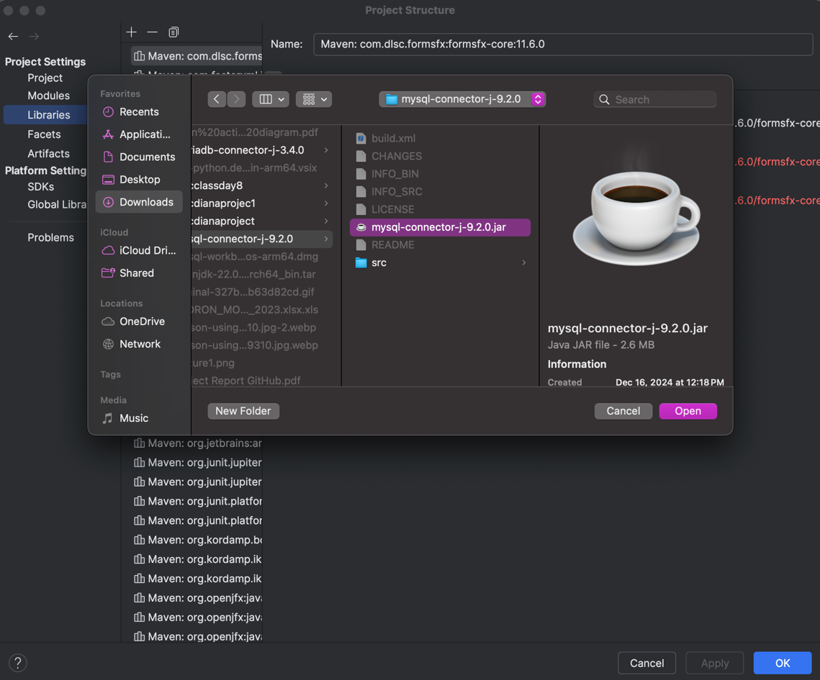

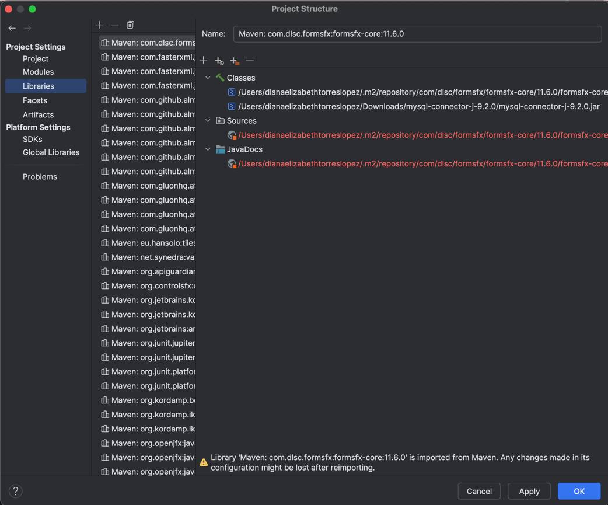

Since we are storing the password hashed. We need to add the dependency in the pom file:

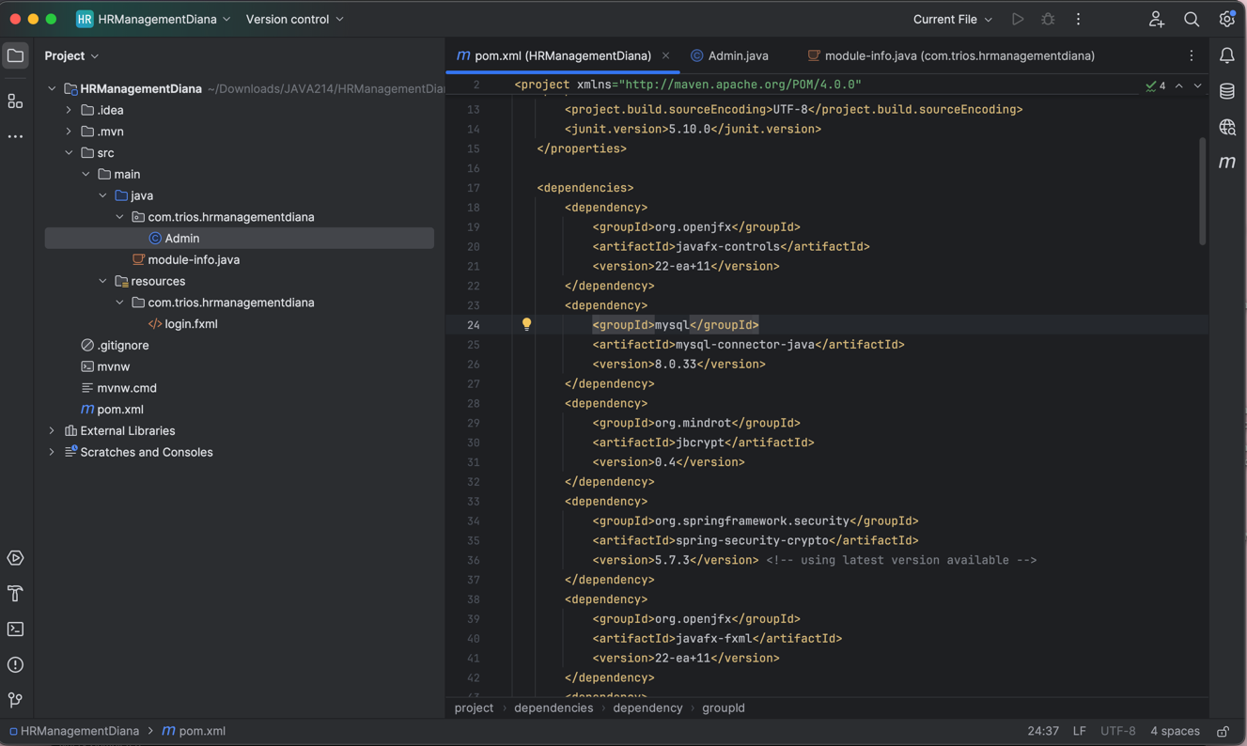

We create the DatabaseConnection class to establish connection:

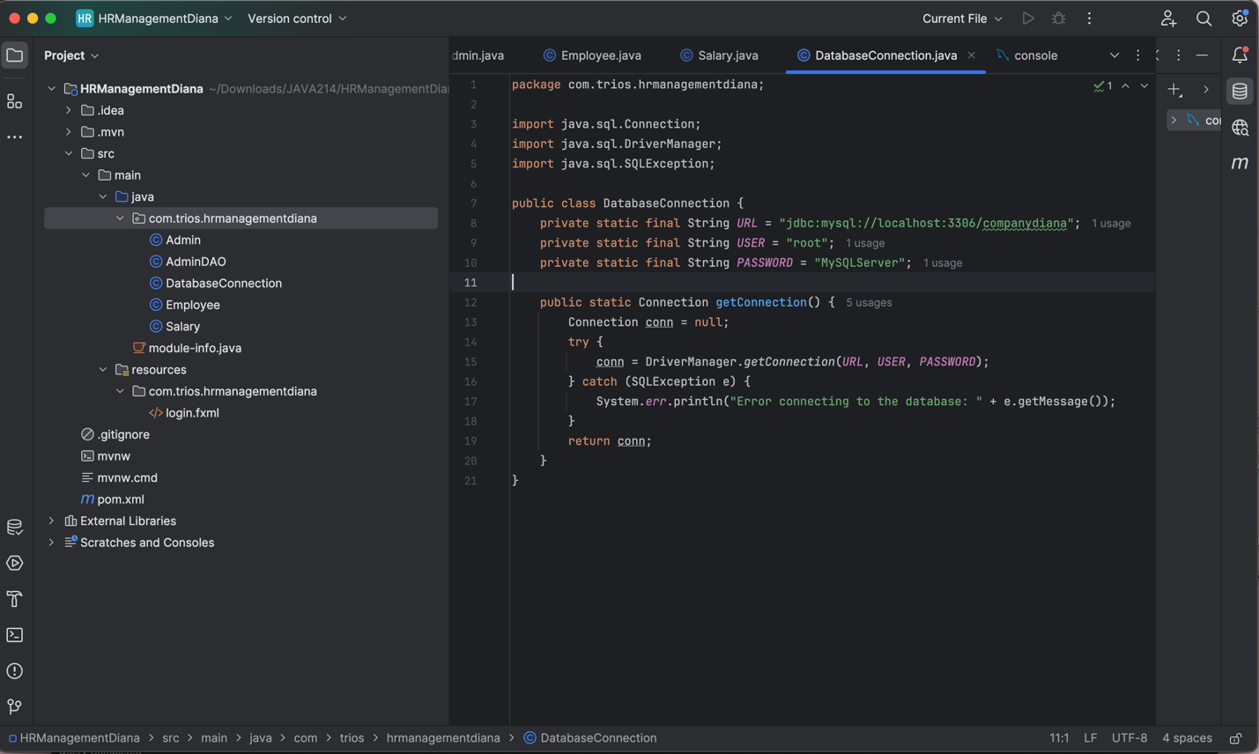

Java Code:

package com.trios.hrmanagementdiana;

import java.sql.Connection;

import java.sql.DriverManager;

import java.sql.SQLException;

public class DatabaseConnection {

private static final String URL = "jdbc:mysql://localhost:3306/companydiana";

private static final String USER = "root";

private static final String PASSWORD = "MySQLServer";

public static Connection getConnection() {

Connection conn = null;

try {

conn = DriverManager.getConnection(URL, USER, PASSWORD);

} catch (SQLException e) {

System.err.println("Error connecting to the database: " + e.getMessage());

}

return conn;

}

}

Then we create the classes to implement Object Relational Mapping. We need to create the following classes:

1. Admin class with constructor, getter and setters. Using ORM to map to the Table Admin.

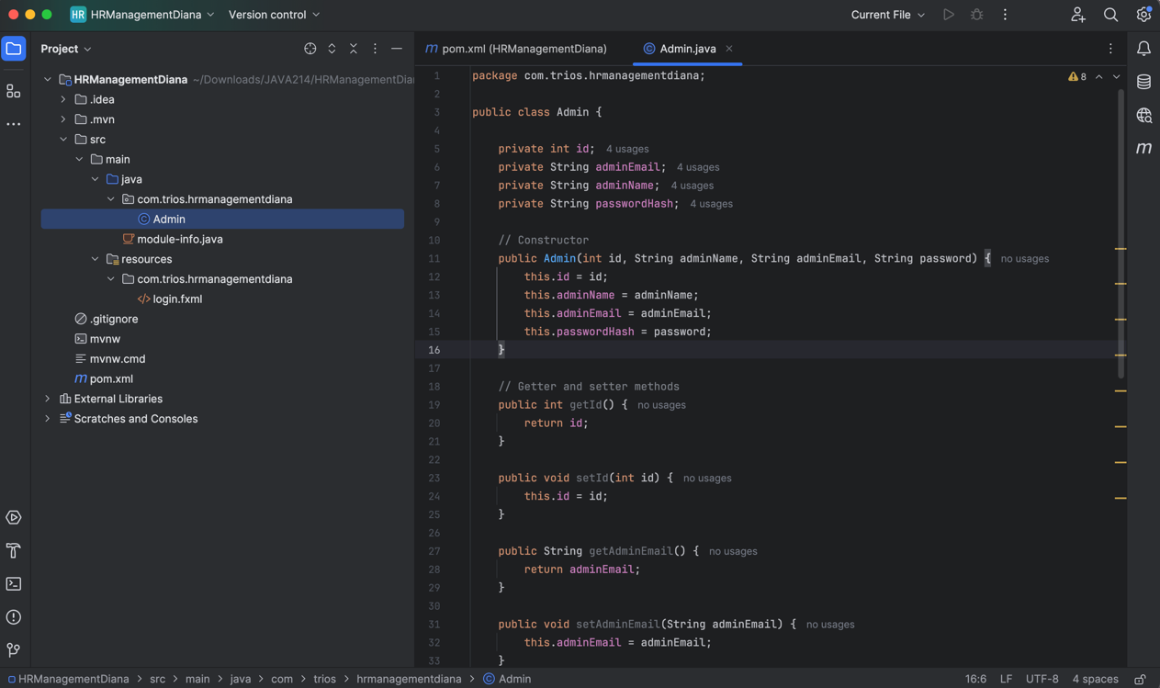

Java Code:

package com.trios.hrmanagementdiana;

public class Admin {

private int id;

private String adminEmail;

private String adminName;

private String passwordHash;

// constructor

public Admin(int id, String adminName, String adminEmail, String password) {

this.id = id;

this.adminName = adminName;

this.adminEmail = adminEmail;

this.passwordHash = password;

}

//getter and setter methods

public int getId() {

return id;

}

public void setId(int id) {

this.id = id;

}

public String getAdminEmail() {

return adminEmail;

}

public void setAdminEmail(String adminEmail) {

this.adminEmail = adminEmail;

}

public String getAdminName() {

return adminName;

}

public void setAdminName(String adminName) {

this.adminName = adminName;

}

public String getPasswordHash() {

return passwordHash;

}

public void setPasswordHash(String passwordHash) {

this.passwordHash = passwordHash;

}

@Override

public String toString() {

return "Admin{" +

"id=" + id +

", adminEmail='" + adminEmail + '\'' +

", adminName='" + adminName + '\'' +

", passwordHash='" + passwordHash + '\'' +

'}';

}

}

1. Employee class with constructor, getters and setters. Using ORM to map to the Table EmployeeDetail.

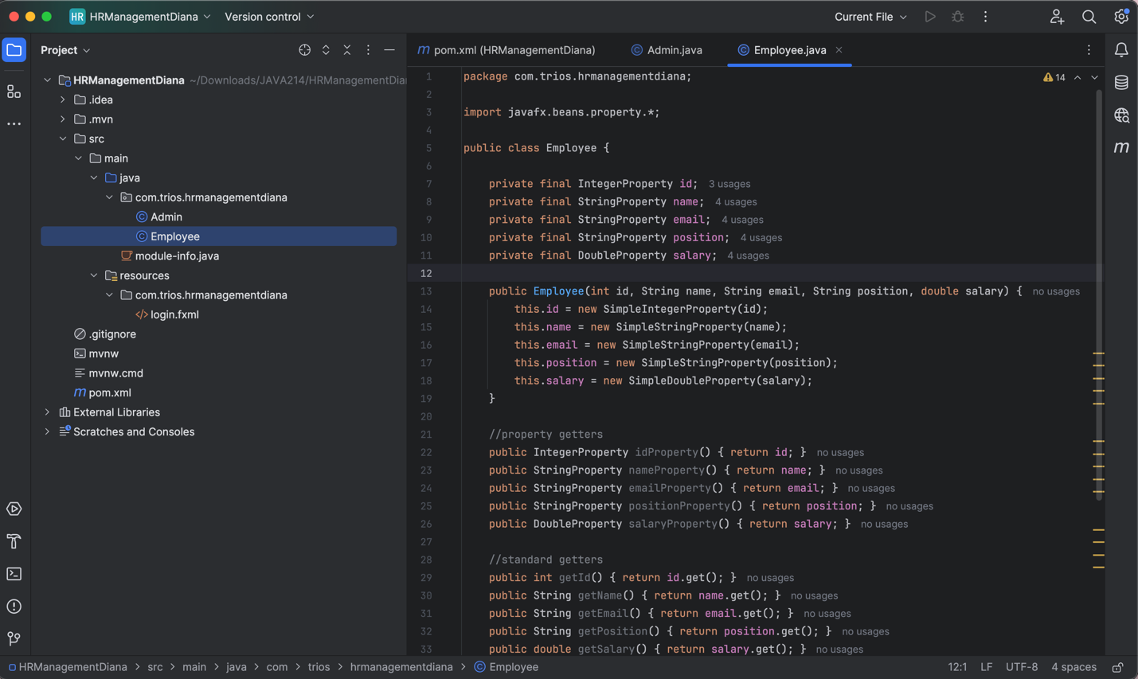

Java Code:

package com.trios.hrmanagementdiana;

import javafx.beans.property.*;

public class Employee {

private final IntegerProperty id;

private final StringProperty name;

private final StringProperty email;

private final StringProperty position;

private final DoubleProperty salary;

public Employee(int id, String name, String email, String position, double salary) {

this.id = new SimpleIntegerProperty(id);

this.name = new SimpleStringProperty(name);

this.email = new SimpleStringProperty(email);

this.position = new SimpleStringProperty(position);

this.salary = new SimpleDoubleProperty(salary);

}

//property getters

public IntegerProperty idProperty() { return id; }

public StringProperty nameProperty() { return name; }

public StringProperty emailProperty() { return email; }

public StringProperty positionProperty() { return position; }

public DoubleProperty salaryProperty() { return salary; }

//standard getters

public int getId() { return id.get(); }

public String getName() { return name.get(); }

public String getEmail() { return email.get(); }

public String getPosition() { return position.get(); }

public double getSalary() { return salary.get(); }

//standard setters

public void setName(String name) { this.name.set(name); }

public void setEmail(String email) { this.email.set(email); }

public void setPosition(String position) { this.position.set(position); }

public void setSalary(double salary) { this.salary.set(salary); }

}

1. Salary class with constructor, getters and setters. Using ORM to map to the Table Salary.

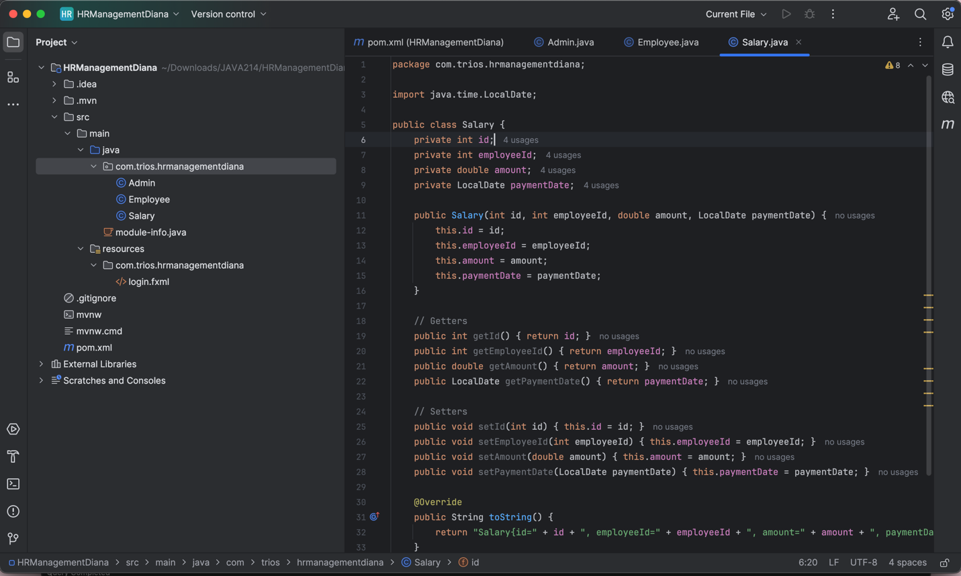

Java Code:

package com.trios.hrmanagementdiana;

import java.time.LocalDate;

public class Salary {

private int id;

private int employeeId;

private double amount;

private LocalDate paymentDate;

public Salary(int id, int employeeId, double amount, LocalDate paymentDate) {

this.id = id;

this.employeeId = employeeId;

this.amount = amount;

this.paymentDate = paymentDate;

}

// Getters

public int getId() { return id; }

public int getEmployeeId() { return employeeId; }

public double getAmount() { return amount; }

public LocalDate getPaymentDate() { return paymentDate; }

// Setters

public void setId(int id) { this.id = id; }

public void setEmployeeId(int employeeId) { this.employeeId = employeeId; }

public void setAmount(double amount) { this.amount = amount; }

public void setPaymentDate(LocalDate paymentDate) { this.paymentDate = paymentDate; }

@Override

public String toString() {

return "Salary{id=" + id + ", employeeId=" + employeeId + ", amount=" + amount + ", paymentDate=" + paymentDate + '}';

}

}

And the following Data Access Object classes:

1. LoginDAO that will handle the Login with methods created.

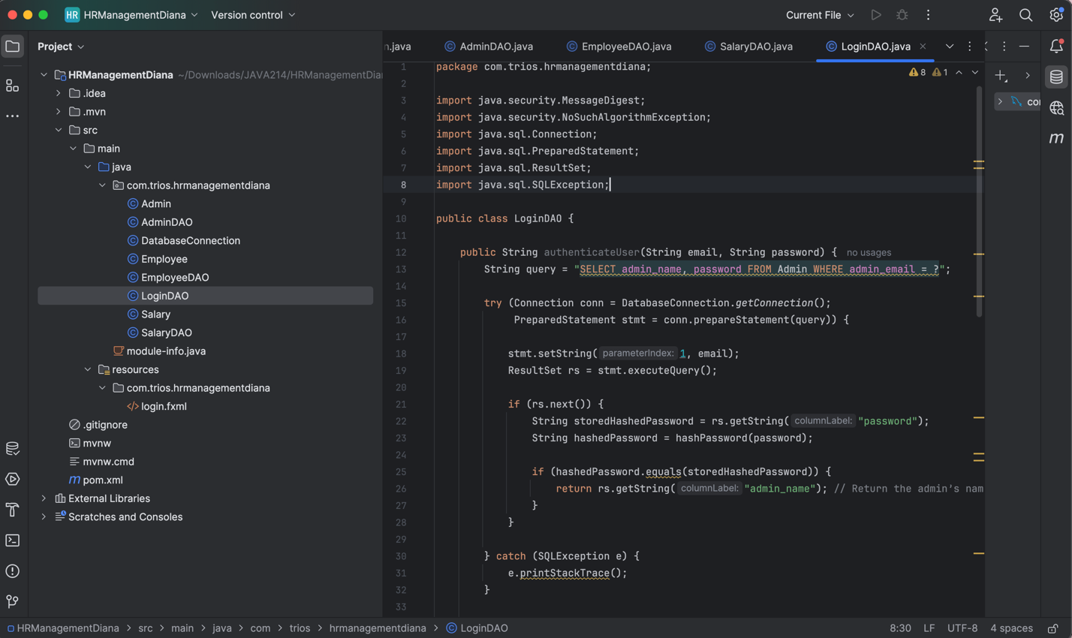

Java Code:

package com.trios.hrmanagementdiana;

import java.security.MessageDigest;

import java.security.NoSuchAlgorithmException;

import java.sql.Connection;

import java.sql.PreparedStatement;

import java.sql.ResultSet;

import java.sql.SQLException;

public class LoginDAO {

public String authenticateUser(String email, String password) {

String query = "SELECT admin_name, password FROM Admin WHERE admin_email = ?";

try (Connection conn = DatabaseConnection.getConnection();

PreparedStatement stmt = conn.prepareStatement(query)) {

stmt.setString(1, email);

ResultSet rs = stmt.executeQuery();

if (rs.next()) {

String storedHashedPassword = rs.getString("password");

String hashedPassword = hashPassword(password);

if (hashedPassword.equals(storedHashedPassword)) {

return rs.getString("admin_name"); // Return the admin’s name if authentication is successful

}

}

} catch (SQLException e) {

e.printStackTrace();

}

return null; // Return null if authentication fails

}

// Helper function to hash passwords using SHA-256

private String hashPassword(String password) {

try {

MessageDigest digest = MessageDigest.getInstance("SHA-256");

byte[] hash = digest.digest(password.getBytes());

StringBuilder hexString = new StringBuilder();

for (byte b : hash) {

hexString.append(String.format("%02x", b));

}

return hexString.toString();

} catch (NoSuchAlgorithmException e) {

e.printStackTrace();

return null;

}

}

public void registerAdmin(String name, String email, String password) {

String query = "INSERT INTO Admin (admin_name, admin_email, password) VALUES (?, ?, ?)";

String hashedPassword = hashPassword(password);

try (Connection conn = DatabaseConnection.getConnection();

PreparedStatement stmt = conn.prepareStatement(query)) {

stmt.setString(1, name);

stmt.setString(2, email);

stmt.setString(3, hashedPassword);

stmt.executeUpdate();

} catch (SQLException e) {

e.printStackTrace();

}

}

}

1. AdminDAO with methods needed

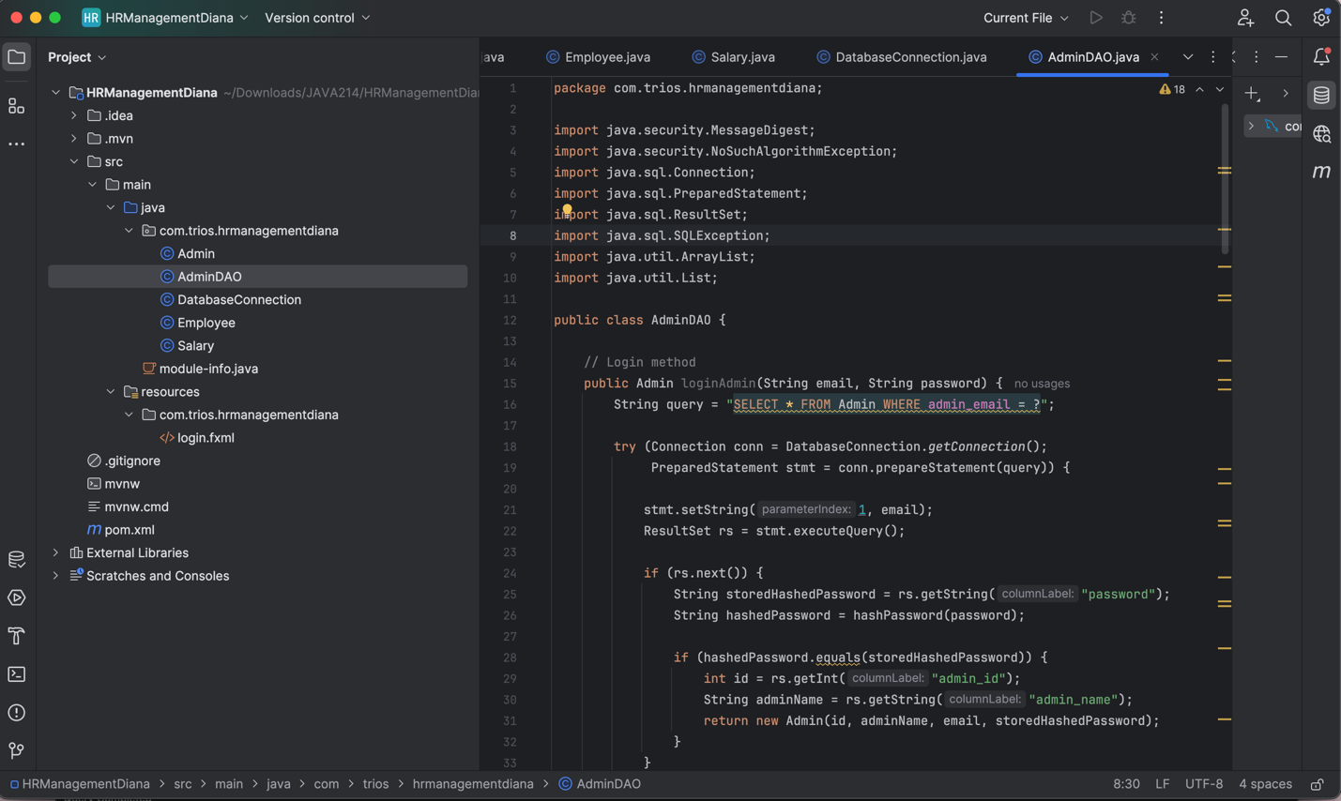

Java Code:

package com.trios.hrmanagementdiana;

import java.security.MessageDigest;

import java.security.NoSuchAlgorithmException;

import java.sql.Connection;

import java.sql.PreparedStatement;

import java.sql.ResultSet;

import java.sql.SQLException;

import java.util.ArrayList;

import java.util.List;

public class AdminDAO {

// Login method

public Admin loginAdmin(String email, String password) {

String query = "SELECT * FROM Admin WHERE admin_email = ?";

try (Connection conn = DatabaseConnection.getConnection();

PreparedStatement stmt = conn.prepareStatement(query)) {

stmt.setString(1, email);

ResultSet rs = stmt.executeQuery();

if (rs.next()) {

String storedHashedPassword = rs.getString("password");

String hashedPassword = hashPassword(password);

if (hashedPassword.equals(storedHashedPassword)) {

int id = rs.getInt("admin_id");

String adminName = rs.getString("admin_name");

return new Admin(id, adminName, email, storedHashedPassword);

}

}

} catch (SQLException e) {

e.printStackTrace();

}

return null;

}

// Add new admin

public void addAdmin(Admin admin) {

String query = "INSERT INTO Admin (admin_name, admin_email, password) VALUES (?, ?, ?)";

String hashedPassword = hashPassword(admin.getPasswordHash());

try (Connection conn = DatabaseConnection.getConnection();

PreparedStatement stmt = conn.prepareStatement(query)) {

stmt.setString(1, admin.getAdminName());

stmt.setString(2, admin.getAdminEmail());

stmt.setString(3, hashedPassword);

stmt.executeUpdate();

} catch (SQLException e) {

e.printStackTrace();

}

}

public List<Admin> getAllAdmins() {

List<Admin> adminList = new ArrayList<>();

String query = "SELECT id, admin_name, admin_email FROM admin"; // Ensure table name is correct

try (Connection conn = DatabaseConnection.getConnection();

PreparedStatement stmt = conn.prepareStatement(query);

ResultSet rs = stmt.executeQuery()) {

while (rs.next()) {

int id = rs.getInt("id");

String name = rs.getString("admin_name");

String email = rs.getString("admin_email");

Admin admin = new Admin(id, name, email, ""); // No password needed

adminList.add(admin);

}

} catch (SQLException e) {

System.err.println("SQL Error in getAllAdmins(): " + e.getMessage());

e.printStackTrace(); // Print full stack trace for debugging

} catch (Exception e) {

System.err.println("Unexpected error in getAllAdmins(): " + e.getMessage());

e.printStackTrace();

}

return adminList;

}

// Update admin details

public void updateAdmin(Admin admin) {

String query = "UPDATE Admin SET admin_name = ?, password = ? WHERE admin_id = ?";

try (Connection conn = DatabaseConnection.getConnection();

PreparedStatement stmt = conn.prepareStatement(query)) {

stmt.setString(1, admin.getAdminName());

stmt.setString(2, admin.getPasswordHash());

stmt.setInt(3, admin.getId());

stmt.executeUpdate();

} catch (SQLException e) {

e.printStackTrace();

}

}

// Delete an admin

public void deleteAdmin(int adminId) {

String query = "DELETE FROM Admin WHERE admin_id = ?";

try (Connection conn = DatabaseConnection.getConnection();

PreparedStatement stmt = conn.prepareStatement(query)) {

stmt.setInt(1, adminId);

stmt.executeUpdate();

} catch (SQLException e) {

e.printStackTrace();

}

}

// Password hashing method

private String hashPassword(String password) {

try {

MessageDigest digest = MessageDigest.getInstance("SHA-256");

byte[] hash = digest.digest(password.getBytes());

StringBuilder hexString = new StringBuilder();

for (byte b : hash) {

hexString.append(String.format("%02x", b));

}

return hexString.toString();

} catch (NoSuchAlgorithmException e) {

e.printStackTrace();

return null;

}

}

}

1. EmployeeDAO with methods needed.

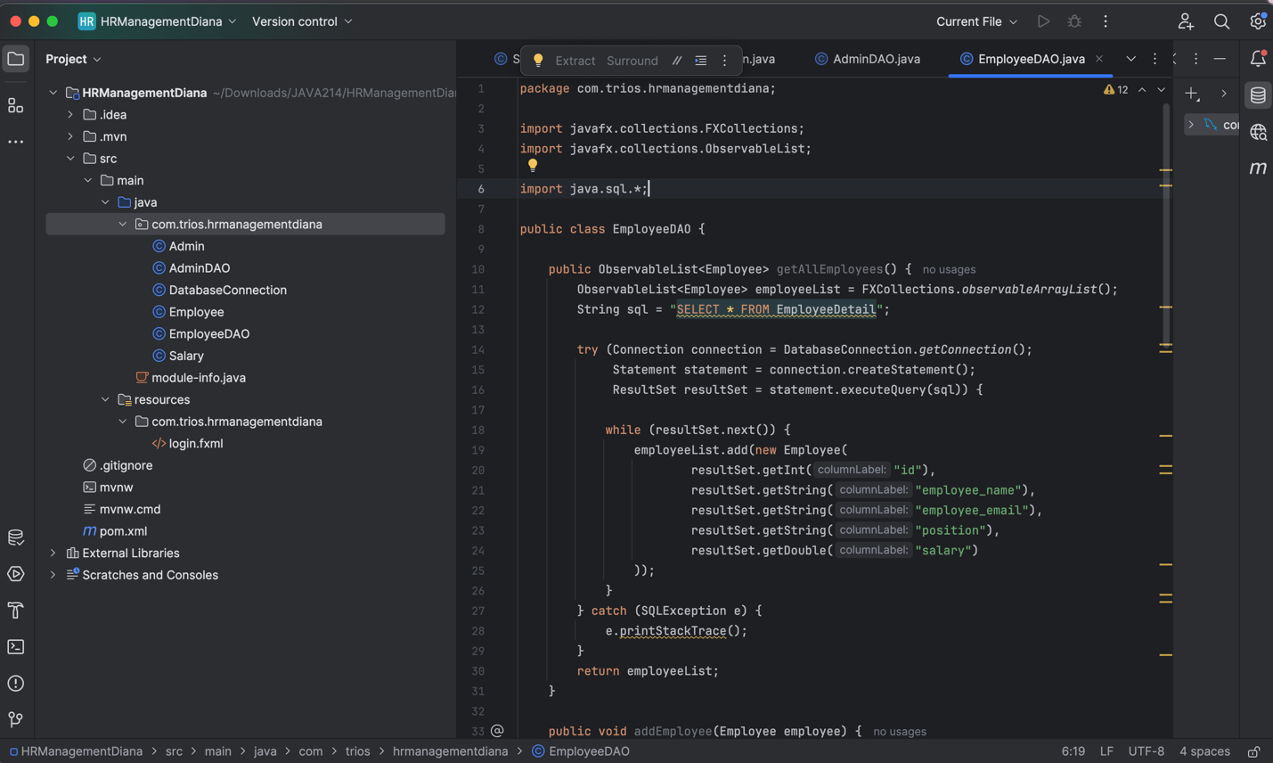

Java Code:

package com.trios.hrmanagementdiana;

import javafx.collections.FXCollections;

import javafx.collections.ObservableList;

import java.sql.*;

public class EmployeeDAO {

public ObservableList<Employee> getAllEmployees() {

ObservableList<Employee> employeeList = FXCollections.observableArrayList();

String sql = "SELECT * FROM EmployeeDetail";

try (Connection connection = DatabaseConnection.getConnection();

Statement statement = connection.createStatement();

ResultSet resultSet = statement.executeQuery(sql)) {

while (resultSet.next()) {

employeeList.add(new Employee(

resultSet.getInt("id"),

resultSet.getString("employee_name"),

resultSet.getString("employee_email"),

resultSet.getString("position"),

resultSet.getDouble("salary")

));

}

} catch (SQLException e) {

e.printStackTrace();

}

return employeeList;

}

public void addEmployee(Employee employee) {

String sql = "INSERT INTO EmployeeDetail (employee_name, employee_email, position, salary) VALUES (?, ?, ?, ?)";

try (Connection connection = DatabaseConnection.getConnection();

PreparedStatement preparedStatement = connection.prepareStatement(sql)) {

preparedStatement.setString(1, employee.getName());

preparedStatement.setString(2, employee.getEmail());

preparedStatement.setString(3, employee.getPosition());

preparedStatement.setDouble(4, employee.getSalary());

preparedStatement.executeUpdate();

} catch (SQLException e) {

e.printStackTrace();

}

}

public void updateEmployee(Employee employee) {

String sql = "UPDATE EmployeeDetail SET employee_name = ?, employee_email = ?, position = ?, salary = ? WHERE id = ?";

try (Connection connection = DatabaseConnection.getConnection();

PreparedStatement preparedStatement = connection.prepareStatement(sql)) {

preparedStatement.setString(1, employee.getName());

preparedStatement.setString(2, employee.getEmail());

preparedStatement.setString(3, employee.getPosition());

preparedStatement.setDouble(4, employee.getSalary());

preparedStatement.setInt(5, employee.getId());

preparedStatement.executeUpdate();

} catch (SQLException e) {

e.printStackTrace();

}

}

public void deleteEmployee(int id) {

String sql = "DELETE FROM EmployeeDetail WHERE id = ?";

try (Connection connection = DatabaseConnection.getConnection();

PreparedStatement preparedStatement = connection.prepareStatement(sql)) {

preparedStatement.setInt(1, id);

preparedStatement.executeUpdate();

} catch (SQLException e) {

e.printStackTrace();

}

}

}

1. SalaryDAO with method needed for yearlySalary.

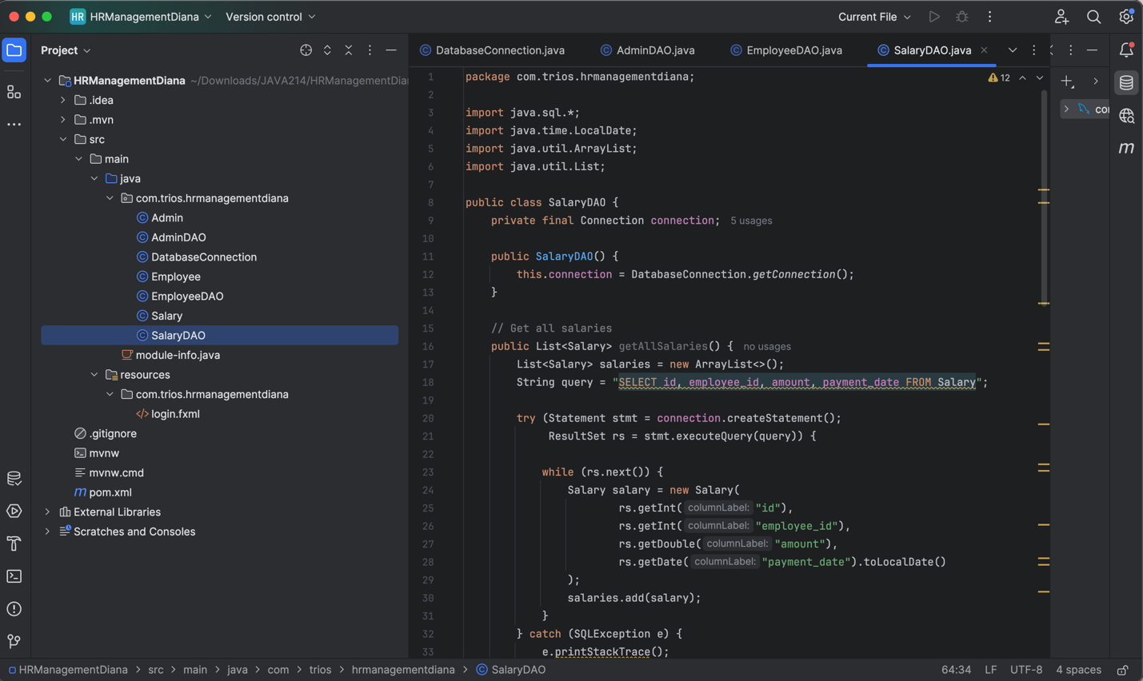

Java Code:

package com.trios.hrmanagementdiana;

import java.sql.*;

import java.time.LocalDate;

import java.util.ArrayList;

import java.util.List;

public class SalaryDAO {

private final Connection connection;

public SalaryDAO() {

this.connection = DatabaseConnection.getConnection();

}

// Get all salaries

public List<Salary> getAllSalaries() {

List<Salary> salaries = new ArrayList<>();

String query = "SELECT id, employee_id, amount, payment_date FROM Salary";

try (Statement stmt = connection.createStatement();

ResultSet rs = stmt.executeQuery(query)) {

while (rs.next()) {

Salary salary = new Salary(

rs.getInt("id"),

rs.getInt("employee_id"),

rs.getDouble("amount"),

rs.getDate("payment_date").toLocalDate()

);

salaries.add(salary);

}

} catch (SQLException e) {

e.printStackTrace();

}

return salaries;

}

// Calculate yearly salary for a given employee ID

public double calculateYearlySalary(int employeeId) {

String query = "SELECT SUM(amount) AS total FROM Salary WHERE employee_id = ?";

double yearlySalary = 0;

try (PreparedStatement stmt = connection.prepareStatement(query)) {

stmt.setInt(1, employeeId);

ResultSet rs = stmt.executeQuery();

if (rs.next()) {

yearlySalary = rs.getDouble("total");

}

} catch (SQLException e) {

e.printStackTrace();

}

return yearlySalary;

}

// Add a salary record

public void addSalary(int employeeId, double amount, LocalDate paymentDate) {

String query = "INSERT INTO Salary (employee_id, amount, payment_date) VALUES (?, ?, ?)";

try (PreparedStatement stmt = connection.prepareStatement(query)) {

stmt.setInt(1, employeeId);

stmt.setDouble(2, amount);

stmt.setDate(3, Date.valueOf(paymentDate));

stmt.executeUpdate();

} catch (SQLException e) {

e.printStackTrace();

}

}

// Clear all salary records (useful for tests)

public void clearSalaries() {

String query = "DELETE FROM Salary";

try (Statement stmt = connection.createStatement()) {

stmt.executeUpdate(query);

} catch (SQLException e) {

e.printStackTrace();

}

}

}

Then, we proceed creating the controller that will handle all the logic of methods.

1. LoginController

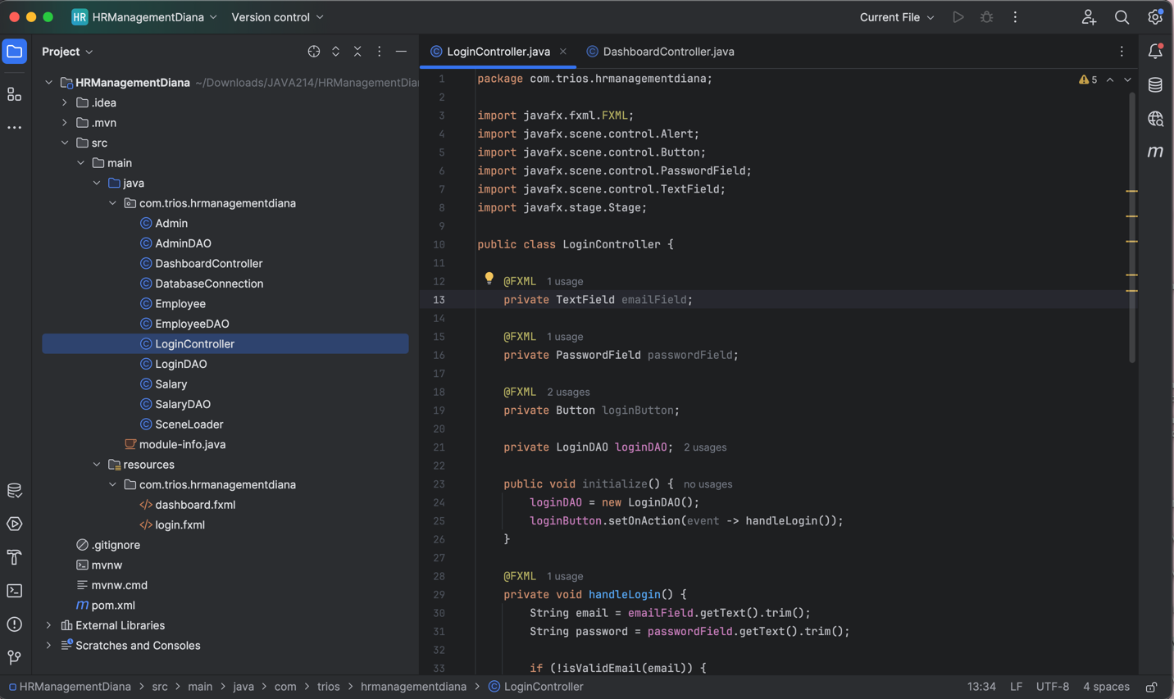

Java Code:

package com.trios.hrmanagementdiana;

import javafx.fxml.FXML;

import javafx.scene.control.Alert;

import javafx.scene.control.Button;

import javafx.scene.control.PasswordField;

import javafx.scene.control.TextField;

import javafx.stage.Stage;

public class LoginController {

@FXML

private TextField emailField;

@FXML

private PasswordField passwordField;

@FXML

private Button loginButton;

private LoginDAO loginDAO;

public void initialize() {

loginDAO = new LoginDAO();

loginButton.setOnAction(event -> handleLogin());

}

@FXML

private void handleLogin() {

String email = emailField.getText().trim();

String password = passwordField.getText().trim();

if (!isValidEmail(email)) {

showAlert("Invalid Email", "Please enter a valid email address.");

return;

}

if (password.isEmpty()) {

showAlert("Empty Password", "Password field cannot be empty.");

return;

}

// Authenticate user and get the admin name

String adminName = loginDAO.authenticateUser(email, password);

if (adminName != null) {

// Pass adminName to the dashboard

SceneLoader.loadSceneWithAdminName((Stage) loginButton.getScene().getWindow(), "dashboard.fxml", adminName);

} else {

showAlert("Login Failed", "Invalid email or password.");

}

}

private boolean isValidEmail(String email) {

return email.contains("@") && email.contains(".");

}

private void showAlert(String title, String message) {

Alert alert = new Alert(Alert.AlertType.ERROR);

alert.setTitle(title);

alert.setHeaderText(null);

alert.setContentText(message);

alert.showAndWait();

}

}

1. AdminController

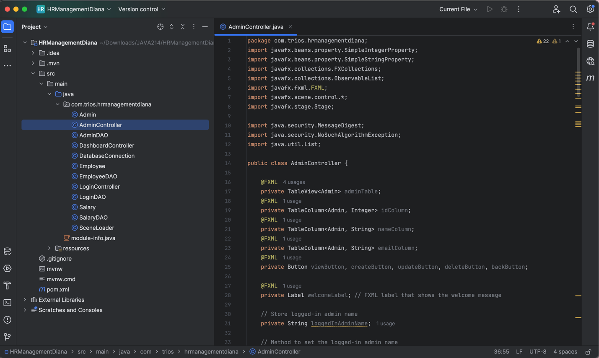

Java Code:

package com.trios.hrmanagementdiana;

import javafx.beans.property.SimpleIntegerProperty;

import javafx.beans.property.SimpleStringProperty;

import javafx.collections.FXCollections;

import javafx.collections.ObservableList;

import javafx.fxml.FXML;

import javafx.scene.control.*;

import javafx.stage.Stage;

import java.security.MessageDigest;

import java.security.NoSuchAlgorithmException;

import java.util.List;

public class AdminController {

@FXML

private TableView<Admin> adminTable;

@FXML

private TableColumn<Admin, Integer> idColumn;

@FXML

private TableColumn<Admin, String> nameColumn;

@FXML

private TableColumn<Admin, String> emailColumn;

@FXML

private Button viewButton, createButton, updateButton, deleteButton, backButton;

@FXML

private Label welcomeLabel; // FXML label that shows the welcome message

// Store logged-in admin name

private String loggedInAdminName;

// Method to set the logged-in admin name

public void setLoggedInAdmin(String adminName) {

this.loggedInAdminName = adminName;

welcomeLabel.setText("Welcome, " + adminName);

}

private AdminDAO adminDAO = new AdminDAO();

private ObservableList<Admin> adminList = FXCollections.observableArrayList();

@FXML

private void initialize() {

idColumn.setCellValueFactory(cellData -> new SimpleIntegerProperty(cellData.getValue().getId()).asObject());

nameColumn.setCellValueFactory(cellData -> new SimpleStringProperty(cellData.getValue().getAdminName()));

emailColumn.setCellValueFactory(cellData -> new SimpleStringProperty(cellData.getValue().getAdminEmail()));

adminTable.setItems(adminList);

viewButton.setOnAction(event -> handleViewAdmins());

createButton.setOnAction(event -> handleCreateAdmin());

updateButton.setOnAction(event -> handleUpdateAdmin());

deleteButton.setOnAction(event -> handleDeleteAdmin());

}

@FXML

private void handleViewAdmins() {

adminList.clear();

List<Admin> admin = adminDAO.getAllAdmins();

if (admin.isEmpty()) {

showAlert("No Admins", "No admins were found in the database.");

} else {

adminList.addAll(admin);

adminTable.setItems(adminList);

}

}

@FXML

private void handleCreateAdmin() {

TextInputDialog nameDialog = new TextInputDialog();

nameDialog.setTitle("Create Admin");

nameDialog.setHeaderText("Enter Admin Name:");

String name = nameDialog.showAndWait().orElse(null);

if (name == null || name.trim().isEmpty()) {

showAlert("Invalid Input", "Admin name cannot be empty.");

return;

}

TextInputDialog emailDialog = new TextInputDialog();

emailDialog.setTitle("Create Admin");

emailDialog.setHeaderText("Enter Admin Email:");

String email = emailDialog.showAndWait().orElse(null);

if (email == null || email.trim().isEmpty()) {

showAlert("Invalid Input", "Admin email cannot be empty.");

return;

}

TextInputDialog passwordDialog = new TextInputDialog();

passwordDialog.setTitle("Create Admin");

passwordDialog.setHeaderText("Enter Password:");

String password = passwordDialog.showAndWait().orElse(null);

if (password == null || password.trim().isEmpty()) {

showAlert("Invalid Input", "Password cannot be empty.");

return;

}

String hashedPassword = hashPassword(password);

Admin newAdmin = new Admin(0, name, email, hashedPassword);

adminDAO.addAdmin(newAdmin);

handleViewAdmins();

}

@FXML

private void handleUpdateAdmin() {

Admin selectedAdmin = adminTable.getSelectionModel().getSelectedItem();

if (selectedAdmin == null) {

showAlert("No Admin Selected", "Please select an admin to update.");

return;

}

TextInputDialog nameDialog = new TextInputDialog(selectedAdmin.getAdminName());

nameDialog.setTitle("Update Admin");

nameDialog.setHeaderText("Enter new Admin Name:");

String newName = nameDialog.showAndWait().orElse(null);

if (newName == null || newName.trim().isEmpty()) {

showAlert("Invalid Input", "Admin name cannot be empty.");

return;

}

TextInputDialog passwordDialog = new TextInputDialog();

passwordDialog.setTitle("Update Admin");

passwordDialog.setHeaderText("Enter new Password (Leave blank to keep current):");

String newPassword = passwordDialog.showAndWait().orElse(null);

if (newPassword != null && !newPassword.trim().isEmpty()) {

String hashedPassword = hashPassword(newPassword);

selectedAdmin.setPasswordHash(hashedPassword);

}

selectedAdmin.setAdminName(newName);

adminDAO.updateAdmin(selectedAdmin);

handleViewAdmins();

}

@FXML

private void handleDeleteAdmin() {

Admin selectedAdmin = adminTable.getSelectionModel().getSelectedItem();

if (selectedAdmin == null) {

showAlert("No Admin Selected", "Please select an admin to delete.");

return;

}

Alert confirmation = new Alert(Alert.AlertType.CONFIRMATION);

confirmation.setTitle("Delete Admin");

confirmation.setHeaderText("Are you sure you want to delete this admin?");

confirmation.setContentText("Admin: " + selectedAdmin.getAdminName());

confirmation.showAndWait().ifPresent(response -> {

if (response == ButtonType.OK) {

adminDAO.deleteAdmin(selectedAdmin.getId());

handleViewAdmins();

}

});

}

@FXML

private void backAction() {

SceneLoader.loadScene((Stage) backButton.getScene().getWindow(), "dashboard.fxml");

}

private String hashPassword(String password) {

try {

MessageDigest digest = MessageDigest.getInstance("SHA-256");

byte[] hash = digest.digest(password.getBytes());

StringBuilder hexString = new StringBuilder();

for (byte b : hash) {

hexString.append(String.format("%02x", b));

}

return hexString.toString();

} catch (NoSuchAlgorithmException e) {

e.printStackTrace();

return null;

}

}

private void showAlert(String title, String content) {

Alert alert = new Alert(Alert.AlertType.INFORMATION);

alert.setTitle(title);

alert.setHeaderText(null);

alert.setContentText(content);

alert.show();

}

}

1. EmployeeDetailsController  
   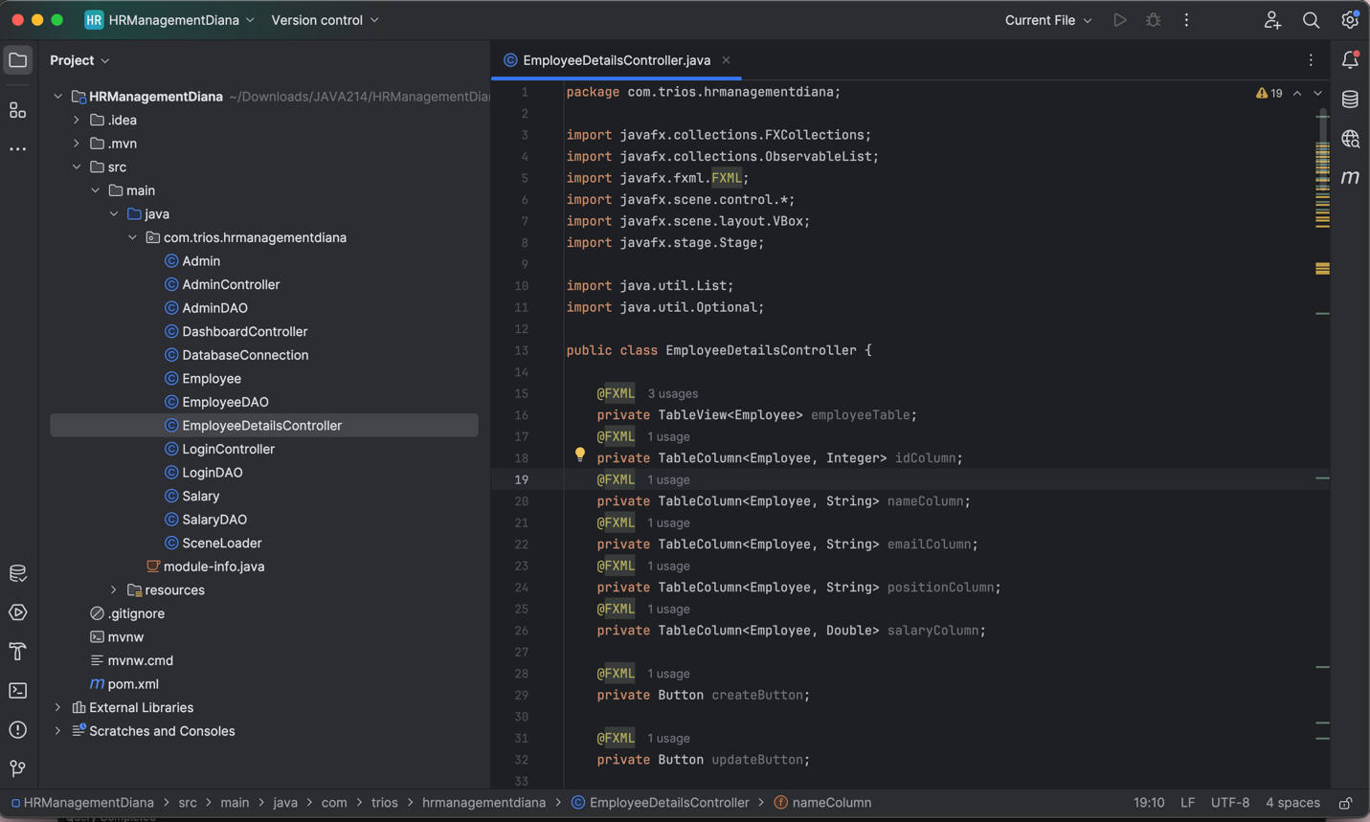

Java Code:

package com.trios.hrmanagementdiana;

import javafx.collections.FXCollections;

import javafx.collections.ObservableList;

import javafx.fxml.FXML;

import javafx.scene.control.*;

import javafx.scene.layout.VBox;

import javafx.stage.Stage;

import java.util.List;

import java.util.Optional;

public class EmployeeDetailsController {

@FXML

private TableView<Employee> employeeTable;

@FXML

private TableColumn<Employee, Integer> idColumn;

@FXML

private TableColumn<Employee, String> nameColumn;

@FXML

private TableColumn<Employee, String> emailColumn;

@FXML

private TableColumn<Employee, String> positionColumn;

@FXML

private TableColumn<Employee, Double> salaryColumn;

@FXML

private Button createButton;

@FXML

private Button updateButton;

@FXML

private Button viewButton;

@FXML

private Button backButton;

@FXML

private Button deleteButton;

private EmployeeDAO employeeDAO = new EmployeeDAO();

private ObservableList<Employee> employeeList = FXCollections.observableArrayList();

public void initialize() {

idColumn.setCellValueFactory(cellData -> cellData.getValue().idProperty().asObject());

nameColumn.setCellValueFactory(cellData -> cellData.getValue().nameProperty());

emailColumn.setCellValueFactory(cellData -> cellData.getValue().emailProperty());

positionColumn.setCellValueFactory(cellData -> cellData.getValue().positionProperty());

salaryColumn.setCellValueFactory(cellData -> cellData.getValue().salaryProperty().asObject());

// Ensure TableView is bound to the ObservableList

employeeTable.setItems(employeeList);

// Loading the data from the database

loadEmployees();

// Setting button actions

createButton.setOnAction(event -> handleCreateEmployee());

updateButton.setOnAction(event -> handleUpdateEmployee());

viewButton.setOnAction(event -> handleViewEmployee());

deleteButton.setOnAction(event -> handleDeleteEmployee());

backButton.setOnAction(event -> backAction());

// Debugging: printing confirmation

System.out.println("EmployeeDetailsController initialized successfully.");

}

private void loadEmployees() {

List<Employee> employees = employeeDAO.getAllEmployees();

System.out.println("Total employees retrieved: " + employees.size()); // Debugging

employeeList.setAll(employees); // Update the ObservableList

// No need to call employeeTable.setItems(employeeList) again.

}

@FXML

private void handleCreateEmployee() {

// Create a new Dialog to collect employee details

Dialog<Employee> dialog = new Dialog<>();

dialog.setTitle("Create Employee");

dialog.setHeaderText("Enter the details of the new employee");

// Create form fields for name, email, position, and salary

TextField nameField = new TextField();

nameField.setPromptText("Name");

TextField emailField = new TextField();

emailField.setPromptText("Email");

TextField positionField = new TextField();

positionField.setPromptText("Position");

TextField salaryField = new TextField();

salaryField.setPromptText("Salary");

// Add fields to the dialog's content

dialog.getDialogPane().setContent(new VBox(10, nameField, emailField, positionField, salaryField));

// Add OK and Cancel buttons

ButtonType okButtonType = new ButtonType("OK", ButtonBar.ButtonData.OK_DONE);

dialog.getDialogPane().getButtonTypes().addAll(okButtonType, ButtonType.CANCEL);

// Handle OK button click

dialog.setResultConverter(dialogButton -> {

if (dialogButton == okButtonType) {

String name = nameField.getText();

String email = emailField.getText();

String position = positionField.getText();

String salaryText = salaryField.getText();

// Validate inputs

if (name.isEmpty() || email.isEmpty() || position.isEmpty() || salaryText.isEmpty()) {

showAlert(Alert.AlertType.ERROR, "Incomplete Details", "All fields must be filled out.");

return null;

}

try {

double salary = Double.parseDouble(salaryText);

// Create and return the new employee

return new Employee(0, name, email, position, salary);

} catch (NumberFormatException e) {

showAlert(Alert.AlertType.ERROR, "Invalid Salary", "Please enter a valid numeric value for salary.");

return null;

}

}

return null;

});

// Show the dialog and get the result

Optional<Employee> result = dialog.showAndWait();

result.ifPresent(employee -> {

employeeDAO.addEmployee(employee); // Add the new employee to the database

loadEmployees(); // Reload the employee list

});

}

@FXML

private void handleUpdateEmployee() {

Employee selectedEmployee = employeeTable.getSelectionModel().getSelectedItem();

if (selectedEmployee != null) {

// Dialogs for updating employee data

TextInputDialog nameDialog = new TextInputDialog(selectedEmployee.getName());

nameDialog.setTitle("Update Employee");

nameDialog.setHeaderText("Update Employee Details");

nameDialog.setContentText("Name:");

String name = nameDialog.showAndWait().orElse(null);

TextInputDialog emailDialog = new TextInputDialog(selectedEmployee.getEmail());

emailDialog.setTitle("Update Employee");

emailDialog.setHeaderText("Update Employee Details");

emailDialog.setContentText("Email:");

String email = emailDialog.showAndWait().orElse(null);

TextInputDialog positionDialog = new TextInputDialog(selectedEmployee.getPosition());

positionDialog.setTitle("Update Employee");

positionDialog.setHeaderText("Update Employee Details");

positionDialog.setContentText("Position:");

String position = positionDialog.showAndWait().orElse(null);

TextInputDialog salaryDialog = new TextInputDialog(String.valueOf(selectedEmployee.getSalary()));

salaryDialog.setTitle("Update Employee");

salaryDialog.setHeaderText("Update Employee Details");

salaryDialog.setContentText("Salary:");

String salaryInput = salaryDialog.showAndWait().orElse(null);

//validation of inputs

if (name != null && !name.isEmpty() &&

email != null && !email.isEmpty() &&

position != null && !position.isEmpty() &&

salaryInput != null && !salaryInput.isEmpty()) {

try {

double salary = Double.parseDouble(salaryInput);

// Update employee object

selectedEmployee.setName(name);

selectedEmployee.setEmail(email);

selectedEmployee.setPosition(position);

selectedEmployee.setSalary(salary);

// Update in database

employeeDAO.updateEmployee(selectedEmployee);

// Reload data

loadEmployees();

} catch (NumberFormatException e) {

showAlert("Invalid Salary", "Please enter a valid numeric value for salary.");

}

} else {

showAlert("Incomplete Details", "All fields must be filled.");

}

} else {

showAlert("No Employee Selected", "Please select an employee to update.");

}

}

//helper method to show alerts

private void showAlert(String title, String content) {

Alert alert = new Alert(Alert.AlertType.ERROR);

alert.setTitle(title);

alert.setHeaderText(null);

alert.setContentText(content);

alert.showAndWait();

}

//view employees button action

@FXML

private void handleViewEmployee() {

loadEmployees(); // Reload employee data

if (employeeList.isEmpty()) {

showAlert(Alert.AlertType.ERROR, "No Data", "No employee records found in the database.");

} else {

showAlert(Alert.AlertType.INFORMATION, "Data Loaded", "All employee records have been refreshed.");

}

}

// helper method for alerts

private void showAlert(Alert.AlertType alertType, String title, String content) {

Alert alert = new Alert(alertType);

alert.setTitle(title);

alert.setHeaderText(null);

alert.setContentText(content);

alert.showAndWait();

}

//back button action

@FXML

private void backAction() {

SceneLoader.loadScene((Stage) backButton.getScene().getWindow(), "dashboard.fxml");

}

//delete button action

@FXML

private void handleDeleteEmployee() {

Employee selectedEmployee = employeeTable.getSelectionModel().getSelectedItem();

if (selectedEmployee != null) {

Alert alert = new Alert(Alert.AlertType.CONFIRMATION, "Delete " + selectedEmployee.getName() + "?",

ButtonType.YES, ButtonType.NO);

if (alert.showAndWait().filter(ButtonType.YES::equals).isPresent()) {

employeeDAO.deleteEmployee(selectedEmployee.getId());

employeeList.remove(selectedEmployee);

}

}

}

}

1. DashboardController

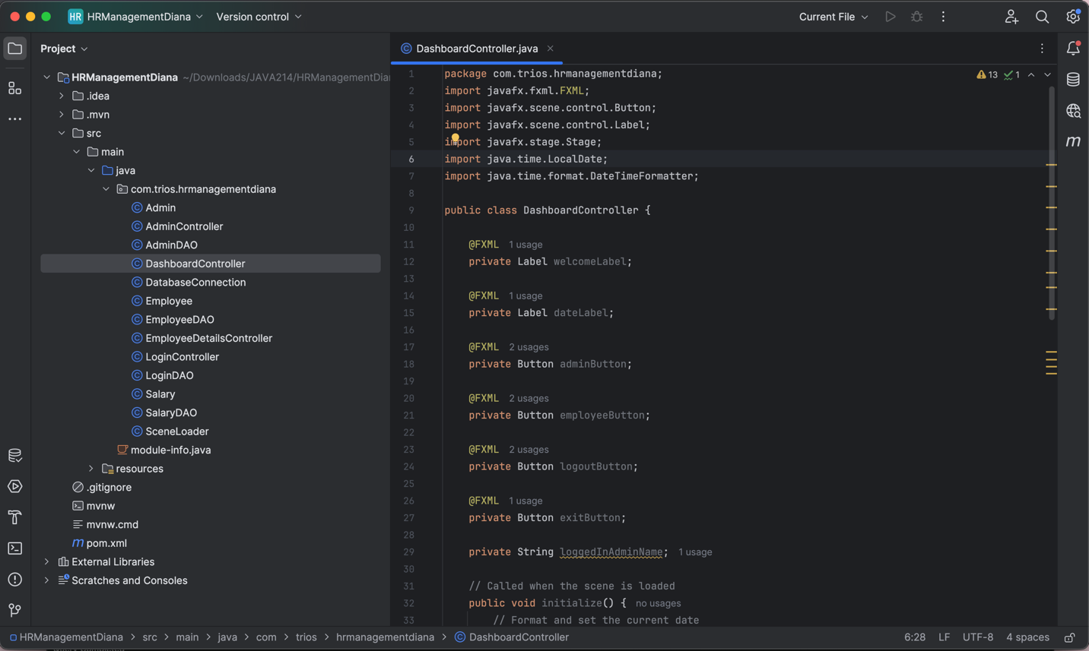

Java Code:

package com.trios.hrmanagementdiana;

import javafx.fxml.FXML;

import javafx.scene.control.Button;

import javafx.scene.control.Label;

import javafx.stage.Stage;

import java.time.LocalDate;

import java.time.format.DateTimeFormatter;

public class DashboardController {

@FXML

private Label welcomeLabel;

@FXML

private Label dateLabel;

@FXML

private Button adminButton;

@FXML

private Button employeeButton;

@FXML

private Button logoutButton;

@FXML

private Button exitButton;

private String loggedInAdminName;

// Called when the scene is loaded

public void initialize() {

// Format and set the current date

DateTimeFormatter formatter = DateTimeFormatter.ofPattern("MMMM dd, yyyy");

dateLabel.setText("Date: " + LocalDate.now().format(formatter));

// Set button actions

adminButton.setOnAction(event -> adminAction());

employeeButton.setOnAction(event -> employeeAction());

logoutButton.setOnAction(event -> logoutAction());

exitButton.setOnAction(event -> exitAction());

}

// Method to load Admin Management Scene

public void adminAction() {

SceneLoader.loadScene((Stage) adminButton.getScene().getWindow(), "admin.fxml");

}

// Method to load Employee Management Scene

public void employeeAction() {

SceneLoader.loadScene((Stage) employeeButton.getScene().getWindow(), "employeedetails.fxml");

}

// Method for logout action

public void logoutAction() {

SceneLoader.loadScene((Stage) logoutButton.getScene().getWindow(), "login.fxml");

}

// Method to exit the application

public void exitAction() {

System.exit(0);

}

// Set the name of the logged-in admin and update the label

public void setLoggedInAdmin(String adminName) {

this.loggedInAdminName = adminName;

welcomeLabel.setText("Welcome, " + adminName);

}

}

Now, we need to create the 4 pages, that the user will see and handle all the logic. These will be the following fxml files:

1. login.fxml

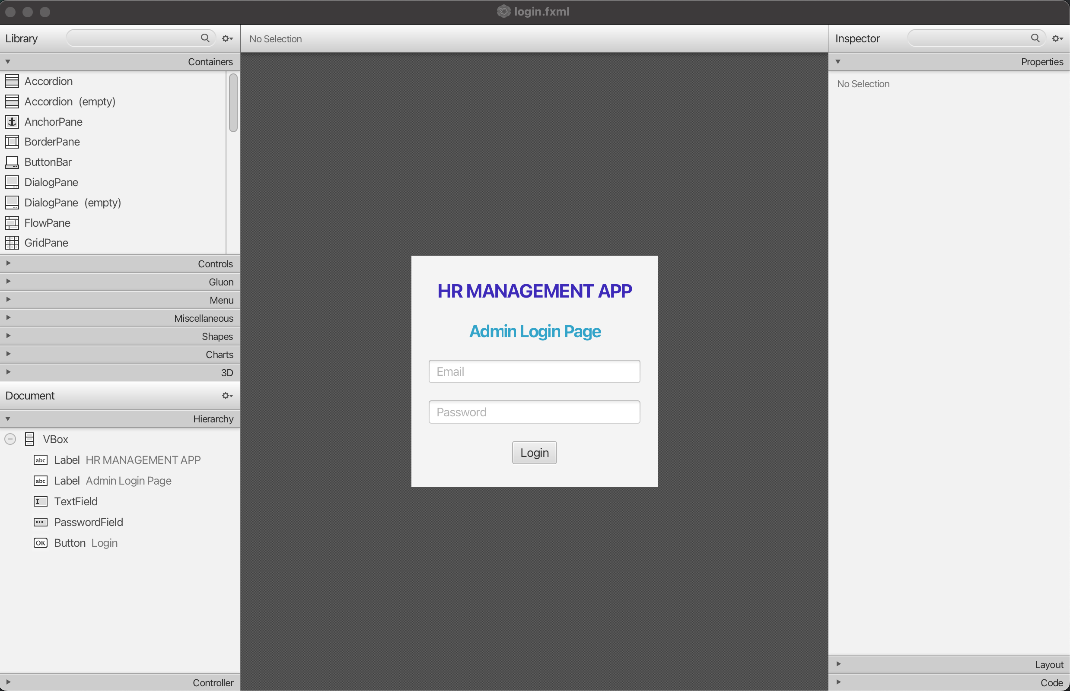

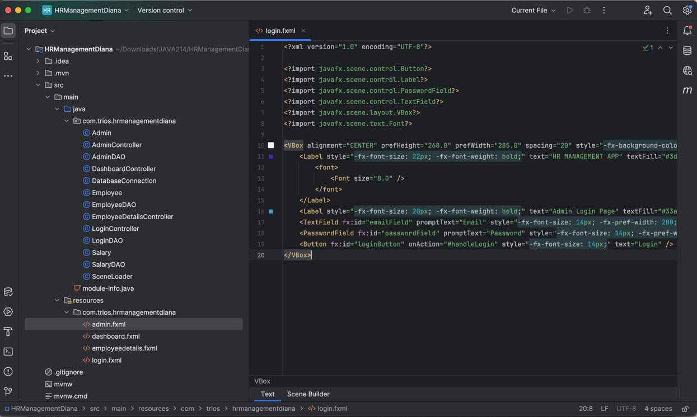

Java Code:

<?xml version="1.0" encoding="UTF-8"?>

<?import javafx.scene.control.Button?>

<?import javafx.scene.control.Label?>

<?import javafx.scene.control.PasswordField?>

<?import javafx.scene.control.TextField?>

<?import javafx.scene.layout.VBox?>

<?import javafx.scene.text.Font?>

<VBox alignment="CENTER" prefHeight="268.0" prefWidth="285.0" spacing="20" style="-fx-background-color: #F4F4F4; -fx-padding: 20;" xmlns:fx="http://javafx.com/fxml/1" xmlns="http://javafx.com/javafx/21" fx:controller="com.trios.hrmanagementdiana.LoginController">

<Label style="-fx-font-size: 22px; -fx-font-weight: bold;" text="HR MANAGEMENT APP" textFill="#3d2ab9">

<font>

<Font size="8.0" />

</font>

</Label>

<Label style="-fx-font-size: 20px; -fx-font-weight: bold;" text="Admin Login Page" textFill="#33a4c9" />

<TextField fx:id="emailField" promptText="Email" style="-fx-font-size: 14px; -fx-pref-width: 200;" />

<PasswordField fx:id="passwordField" promptText="Password" style="-fx-font-size: 14px; -fx-pref-width: 200;" />

<Button fx:id="loginButton" onAction="#handleLogin" style="-fx-font-size: 14px;" text="Login" />

</VBox>

1. admin.fxml

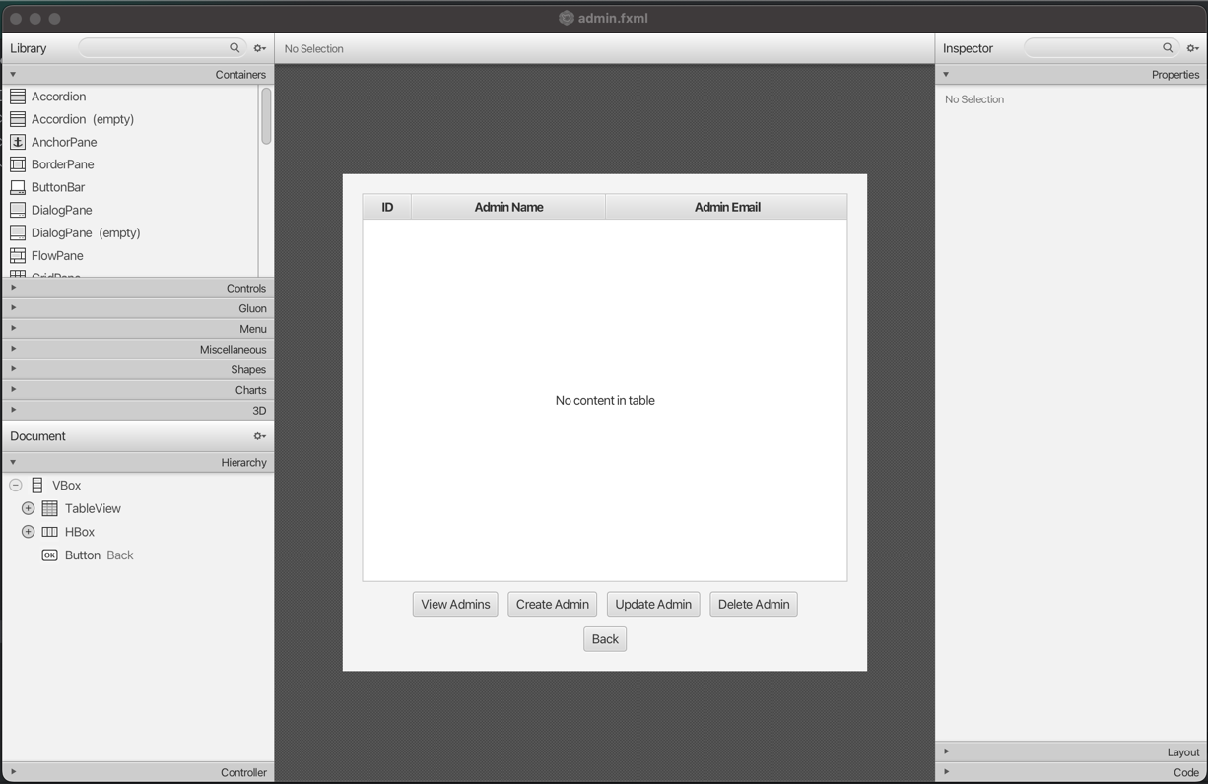

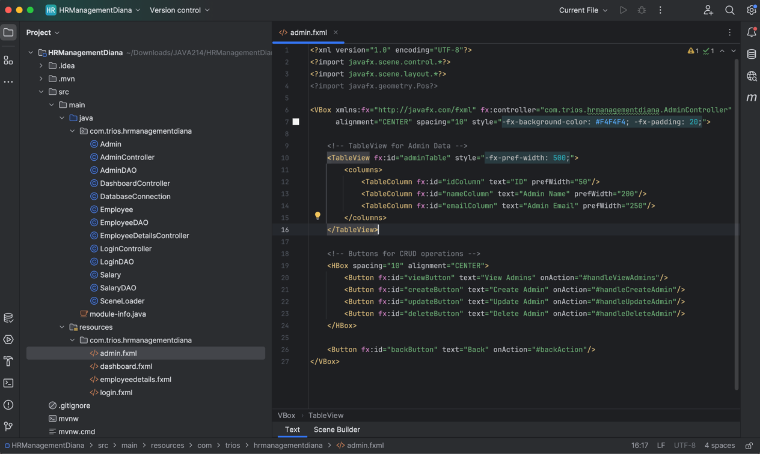

Java Code:

<?xml version="1.0" encoding="UTF-8"?>

<?import javafx.scene.control.*?>

<?import javafx.scene.layout.*?>

<?import javafx.geometry.Pos?>

<VBox xmlns:fx="http://javafx.com/fxml" fx:controller="com.trios.hrmanagementdiana.AdminController"

alignment="CENTER" spacing="10" style="-fx-background-color: #F4F4F4; -fx-padding: 20;">

<!-- TableView for Admin Data -->

<TableView fx:id="adminTable" style="-fx-pref-width: 500;">

<columns>

<TableColumn fx:id="idColumn" text="ID" prefWidth="50"/>

<TableColumn fx:id="nameColumn" text="Admin Name" prefWidth="200"/>

<TableColumn fx:id="emailColumn" text="Admin Email" prefWidth="250"/>

</columns>

</TableView>

<!-- Buttons for CRUD operations -->

<HBox spacing="10" alignment="CENTER">

<Button fx:id="viewButton" text="View Admins" onAction="#handleViewAdmins"/>

<Button fx:id="createButton" text="Create Admin" onAction="#handleCreateAdmin"/>

<Button fx:id="updateButton" text="Update Admin" onAction="#handleUpdateAdmin"/>

<Button fx:id="deleteButton" text="Delete Admin" onAction="#handleDeleteAdmin"/>

</HBox>

<Button fx:id="backButton" text="Back" onAction="#backAction"/>

</VBox>

1. dashboard.fxml

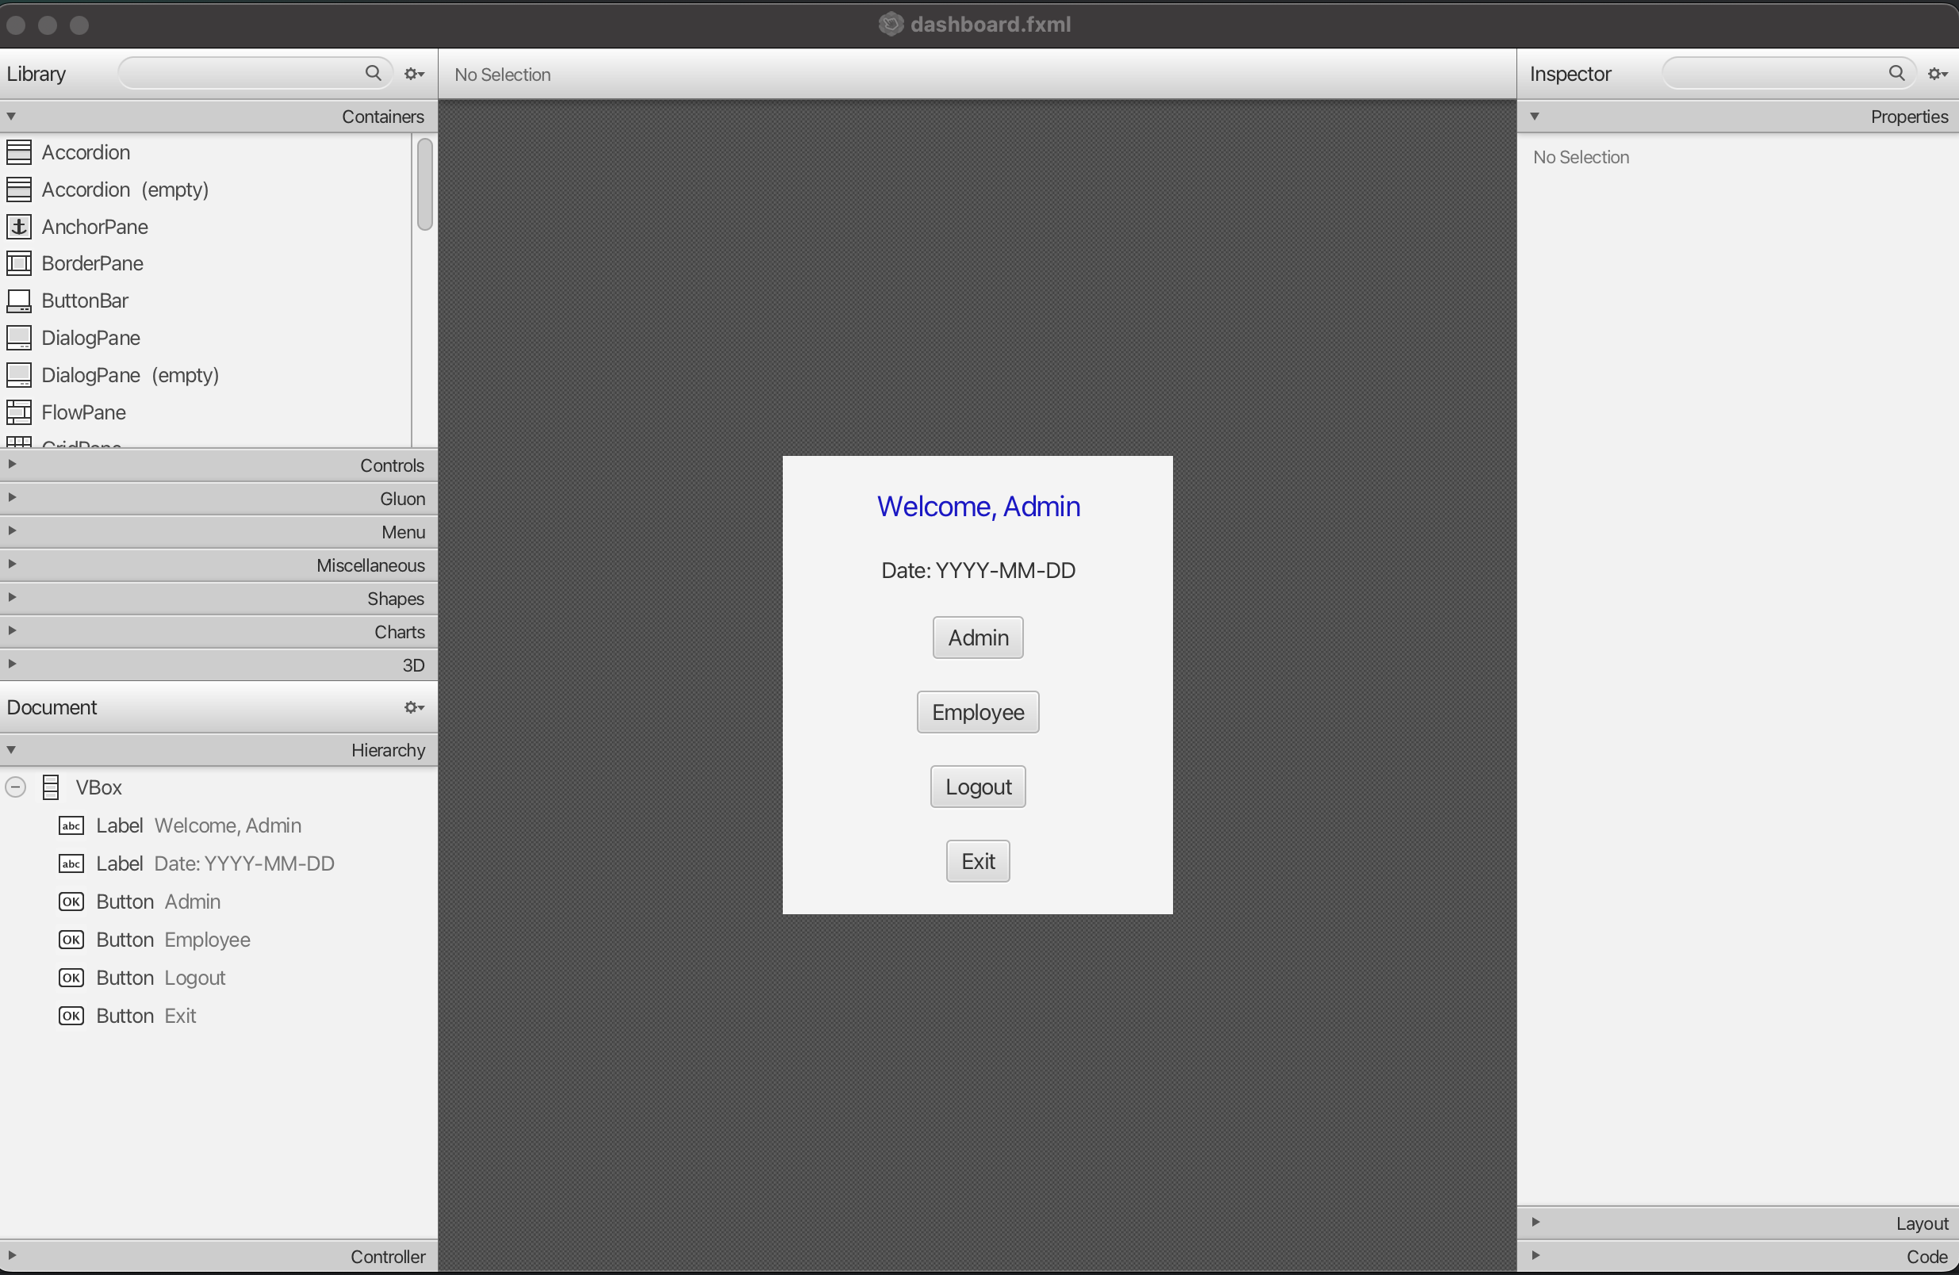

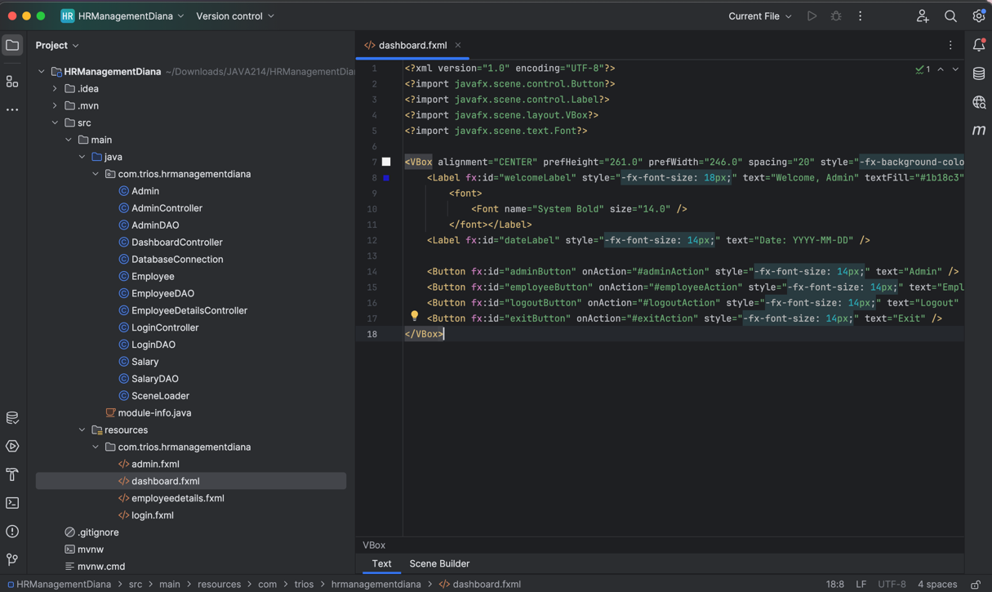

Java Code:

<?xml version="1.0" encoding="UTF-8"?>

<?import javafx.scene.control.Button?>

<?import javafx.scene.control.Label?>

<?import javafx.scene.layout.VBox?>

<?import javafx.scene.text.Font?>

<VBox alignment="CENTER" prefHeight="261.0" prefWidth="246.0" spacing="20" style="-fx-background-color: #F4F4F4; -fx-padding: 20;" xmlns:fx="http://javafx.com/fxml/1" xmlns="http://javafx.com/javafx/21" fx:controller="com.trios.hrmanagementdiana.DashboardController">

<Label fx:id="welcomeLabel" style="-fx-font-size: 18px;" text="Welcome, Admin" textFill="#1b18c3">

<font>

<Font name="System Bold" size="14.0" />

</font></Label>

<Label fx:id="dateLabel" style="-fx-font-size: 14px;" text="Date: YYYY-MM-DD" />

<Button fx:id="adminButton" onAction="#adminAction" style="-fx-font-size: 14px;" text="Admin" />

<Button fx:id="employeeButton" onAction="#employeeAction" style="-fx-font-size: 14px;" text="Employee" />

<Button fx:id="logoutButton" onAction="#logoutAction" style="-fx-font-size: 14px;" text="Logout" />

<Button fx:id="exitButton" onAction="#exitAction" style="-fx-font-size: 14px;" text="Exit" />

</VBox>

1. employeedetails.fxml

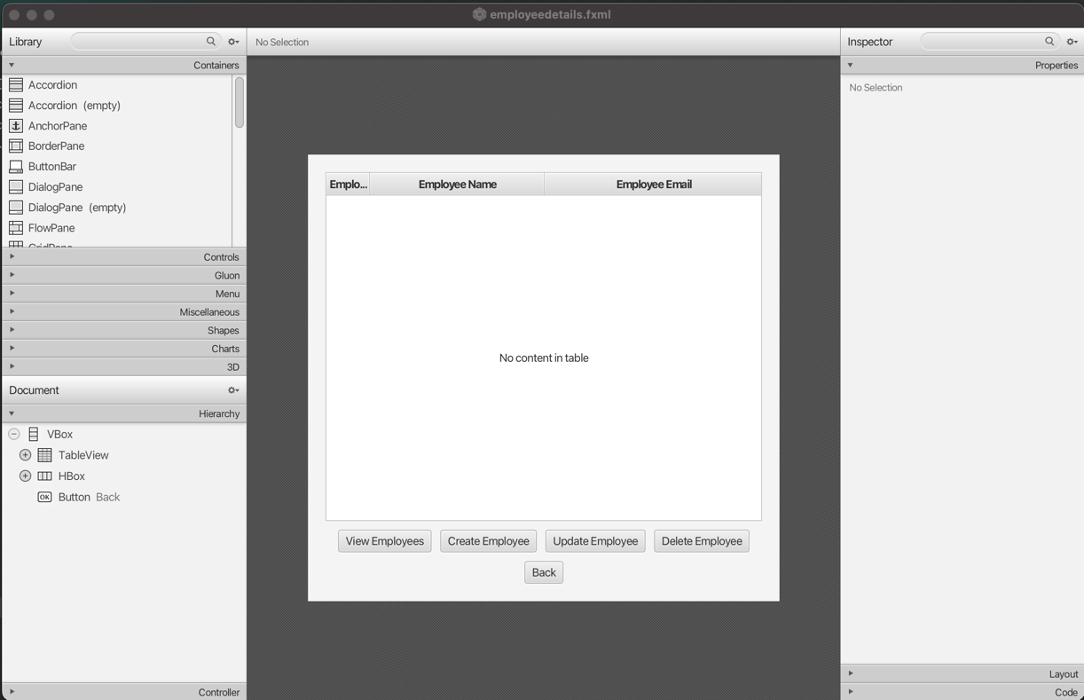

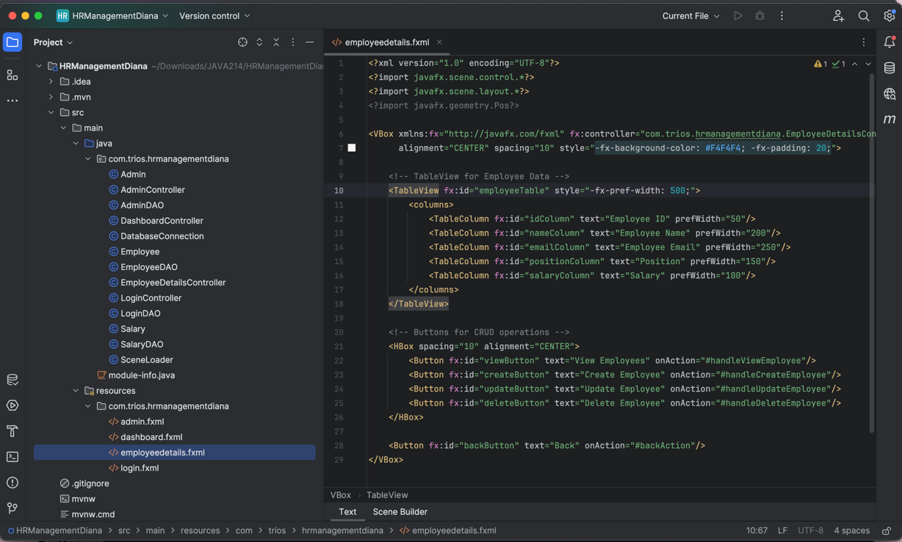

Java Code:

<?xml version="1.0" encoding="UTF-8"?>

<?import javafx.scene.control.*?>

<?import javafx.scene.layout.*?>

<?import javafx.geometry.Pos?>

<VBox xmlns:fx="http://javafx.com/fxml" fx:controller="com.trios.hrmanagementdiana.EmployeeDetailsController"

alignment="CENTER" spacing="10" style="-fx-background-color: #F4F4F4; -fx-padding: 20;">

<!-- TableView for Employee Data -->

<TableView fx:id="employeeTable" style="-fx-pref-width: 500;">

<columns>

<TableColumn fx:id="idColumn" text="Employee ID" prefWidth="50"/>

<TableColumn fx:id="nameColumn" text="Employee Name" prefWidth="200"/>

<TableColumn fx:id="emailColumn" text="Employee Email" prefWidth="250"/>

<TableColumn fx:id="positionColumn" text="Position" prefWidth="150"/>

<TableColumn fx:id="salaryColumn" text="Salary" prefWidth="100"/>

</columns>

</TableView>

<!-- Buttons for CRUD operations -->

<HBox spacing="10" alignment="CENTER">

<Button fx:id="viewButton" text="View Employees" onAction="#handleViewEmployee"/>

<Button fx:id="createButton" text="Create Employee" onAction="#handleCreateEmployee"/>

<Button fx:id="updateButton" text="Update Employee" onAction="#handleUpdateEmployee"/>

<Button fx:id="deleteButton" text="Delete Employee" onAction="#handleDeleteEmployee"/>

</HBox>

<Button fx:id="backButton" text="Back" onAction="#backAction"/>

</VBox>

All these views will be controlled by the class SceneLoader:

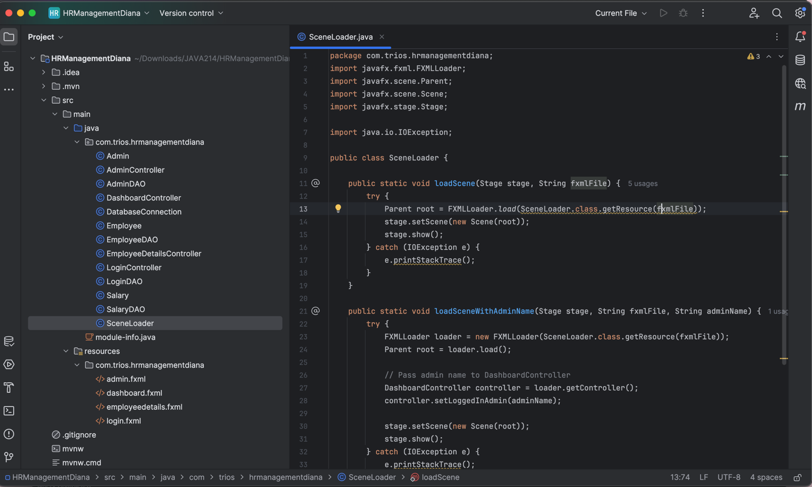

Java Code:

package com.trios.hrmanagementdiana;

import javafx.fxml.FXMLLoader;

import javafx.scene.Parent;

import javafx.scene.Scene;

import javafx.stage.Stage;

import java.io.IOException;

public class SceneLoader {

public static void loadScene(Stage stage, String fxmlFile) {

try {

Parent root = FXMLLoader.load(SceneLoader.class.getResource(fxmlFile));

stage.setScene(new Scene(root));

stage.show();

} catch (IOException e) {

e.printStackTrace();

}

}

public static void loadSceneWithAdminName(Stage stage, String fxmlFile, String adminName) {

try {

FXMLLoader loader = new FXMLLoader(SceneLoader.class.getResource(fxmlFile));

Parent root = loader.load();

// Pass admin name to DashboardController

DashboardController controller = loader.getController();

controller.setLoggedInAdmin(adminName);

stage.setScene(new Scene(root));

stage.show();

} catch (IOException e) {

e.printStackTrace();

}

}

}

Finally, we create the Main class that will run this application.

Main class:

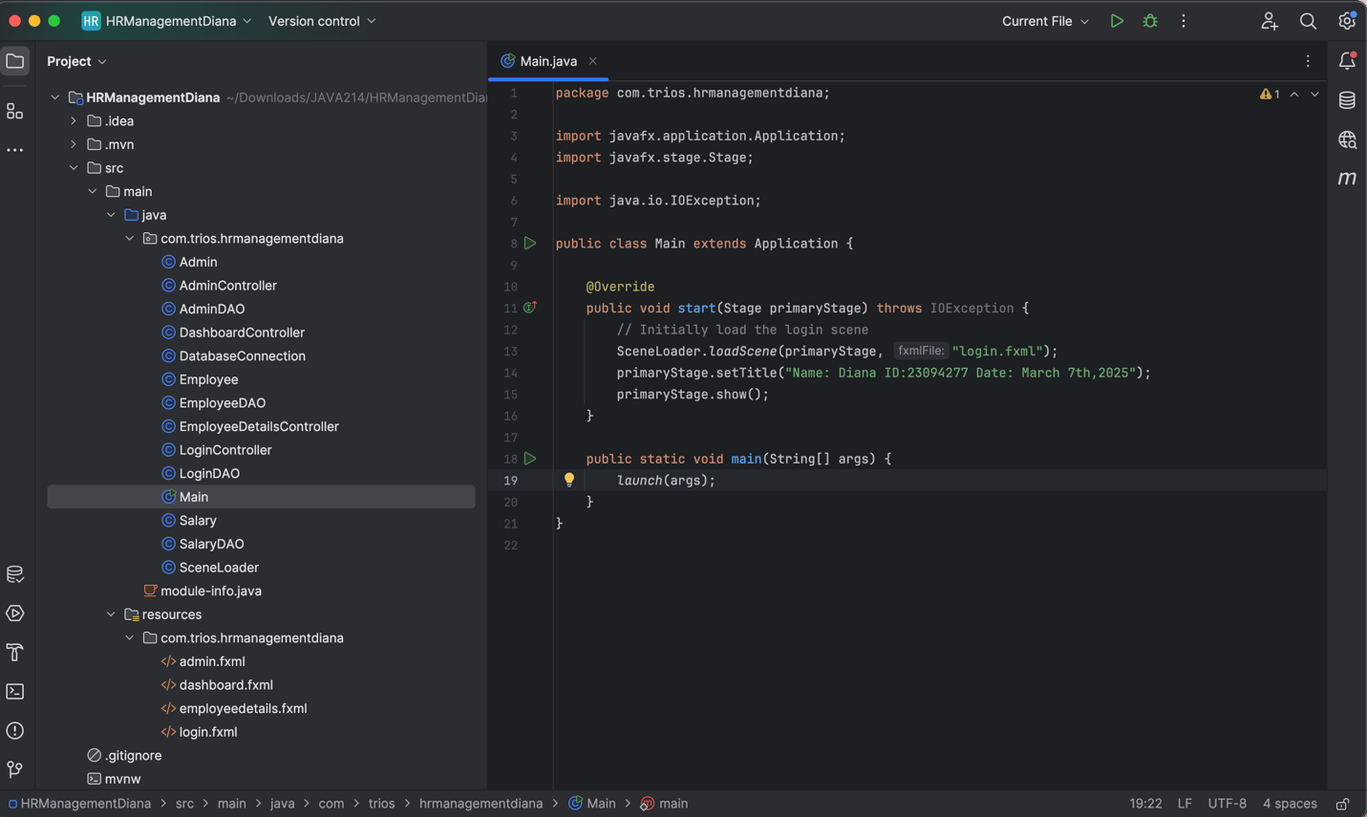

Java Code:

package com.trios.hrmanagementdiana;

import javafx.application.Application;

import javafx.stage.Stage;

import java.io.IOException;

public class Main extends Application {

@Override

public void start(Stage primaryStage) throws IOException {

// Initially load the login scene

SceneLoader.loadScene(primaryStage, "login.fxml");

primaryStage.setTitle("Name: Diana ID:23094277 Date: March 7th,2025");

primaryStage.show();

}

public static void main(String[] args) {

launch(args);

}

}

Screenshots of the app running

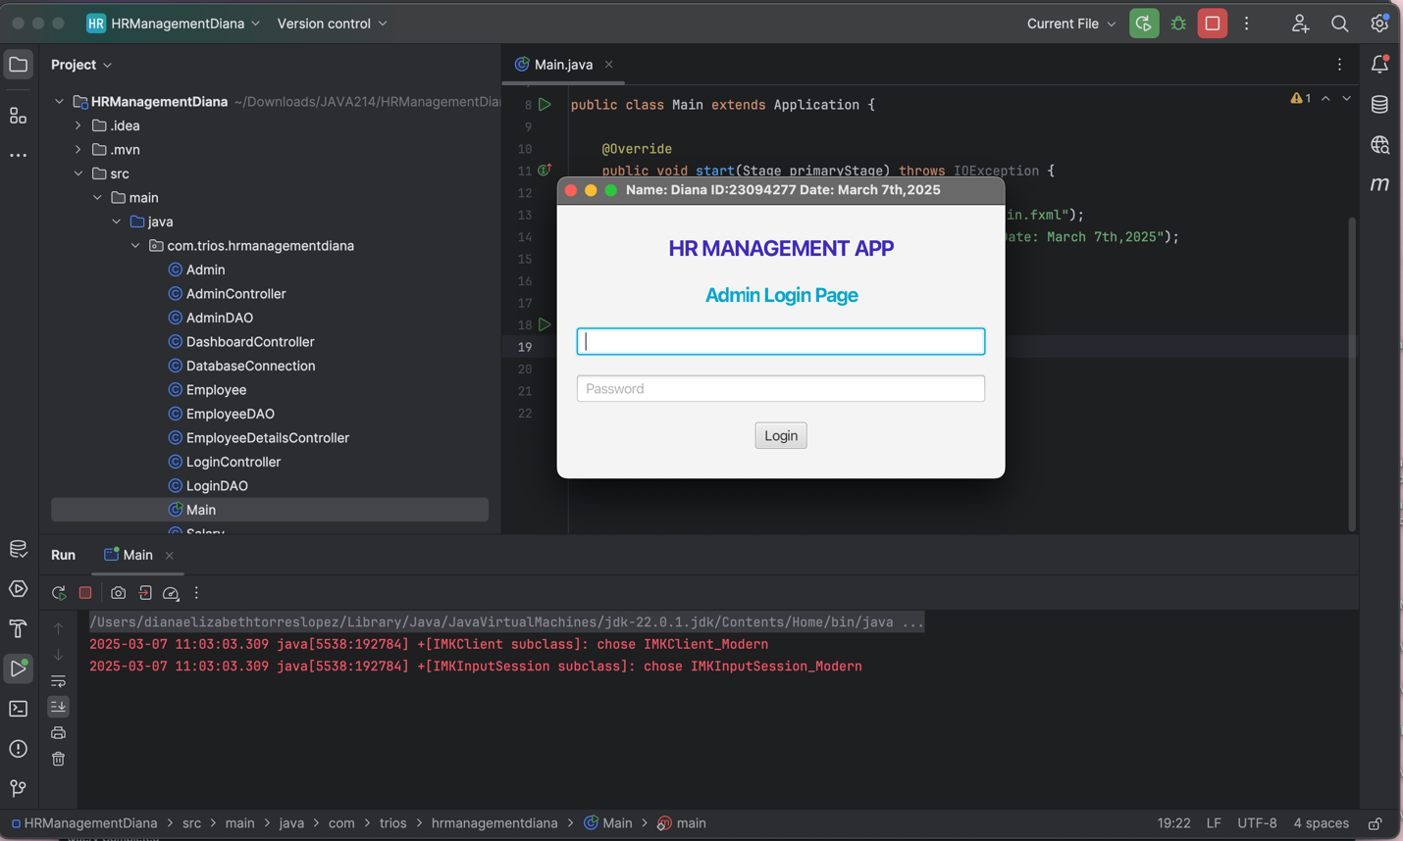

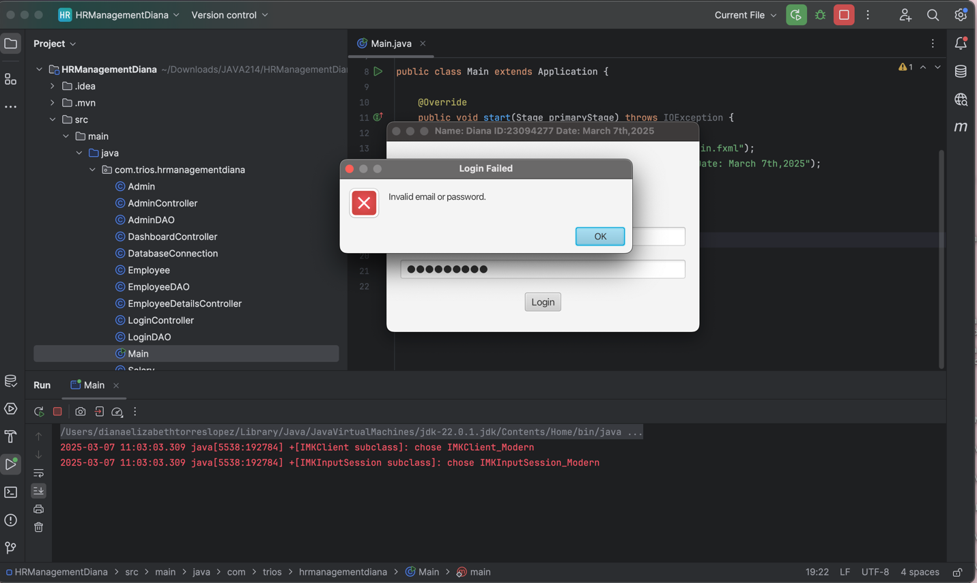

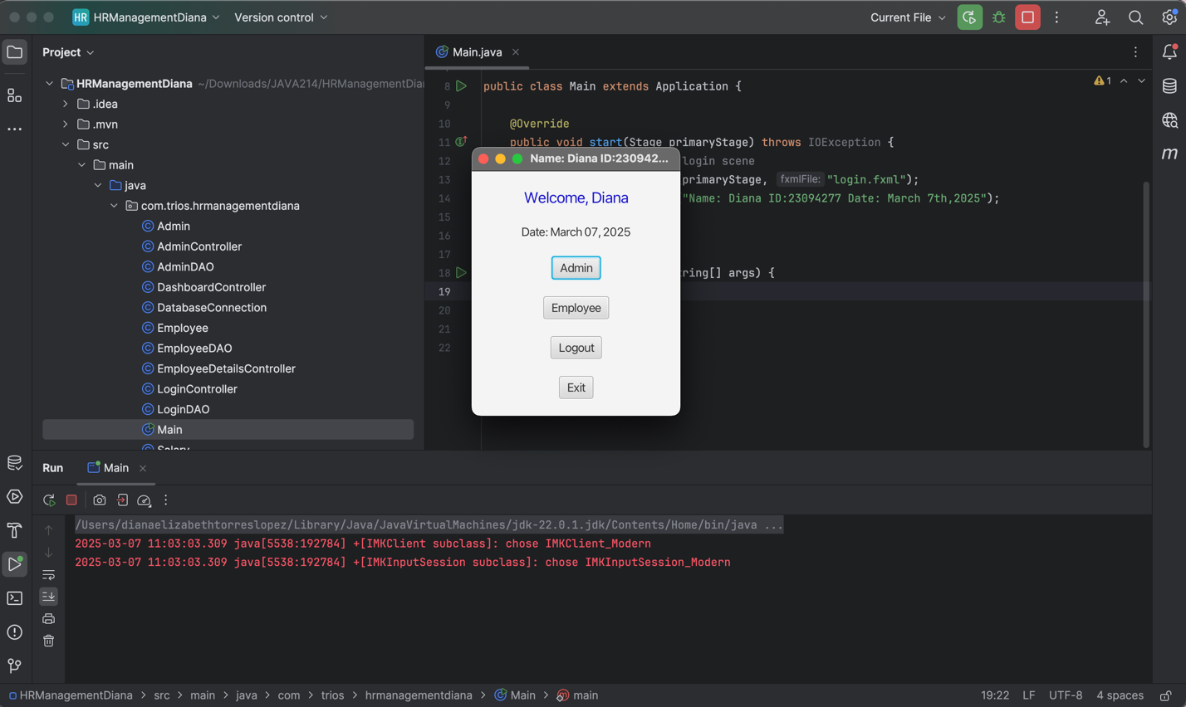

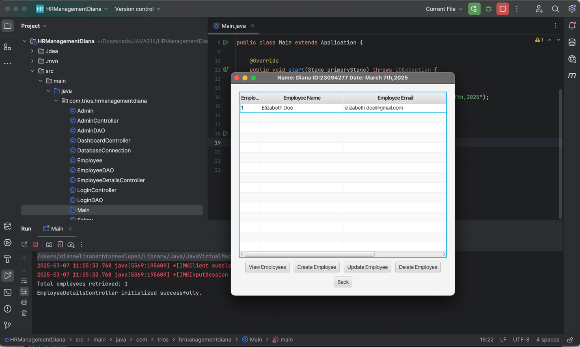

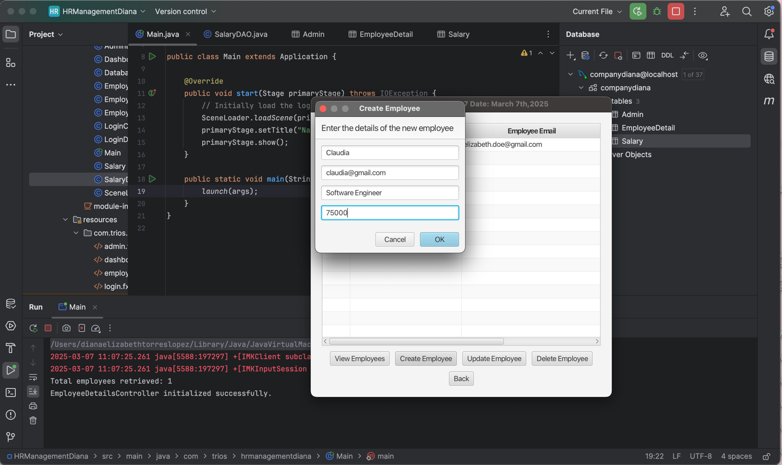

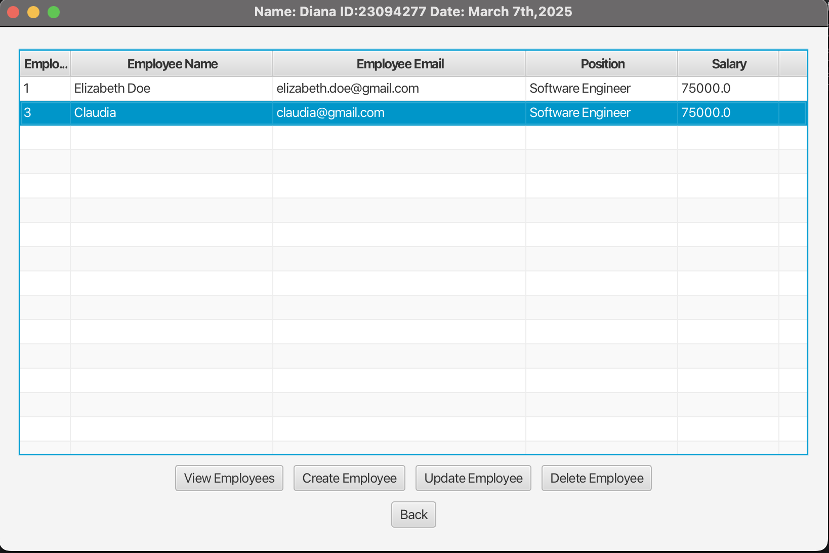

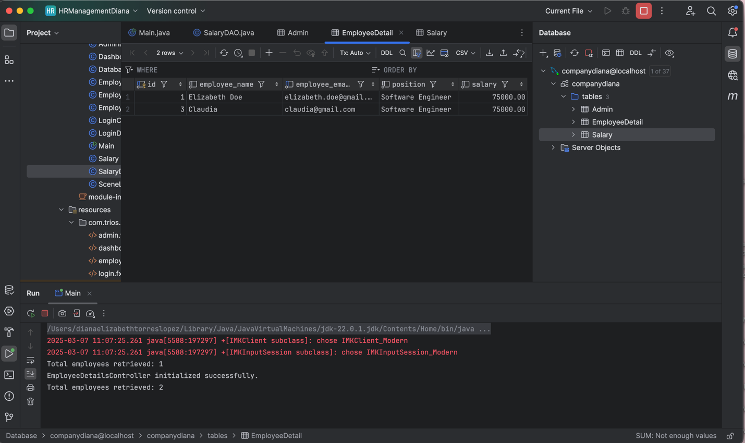

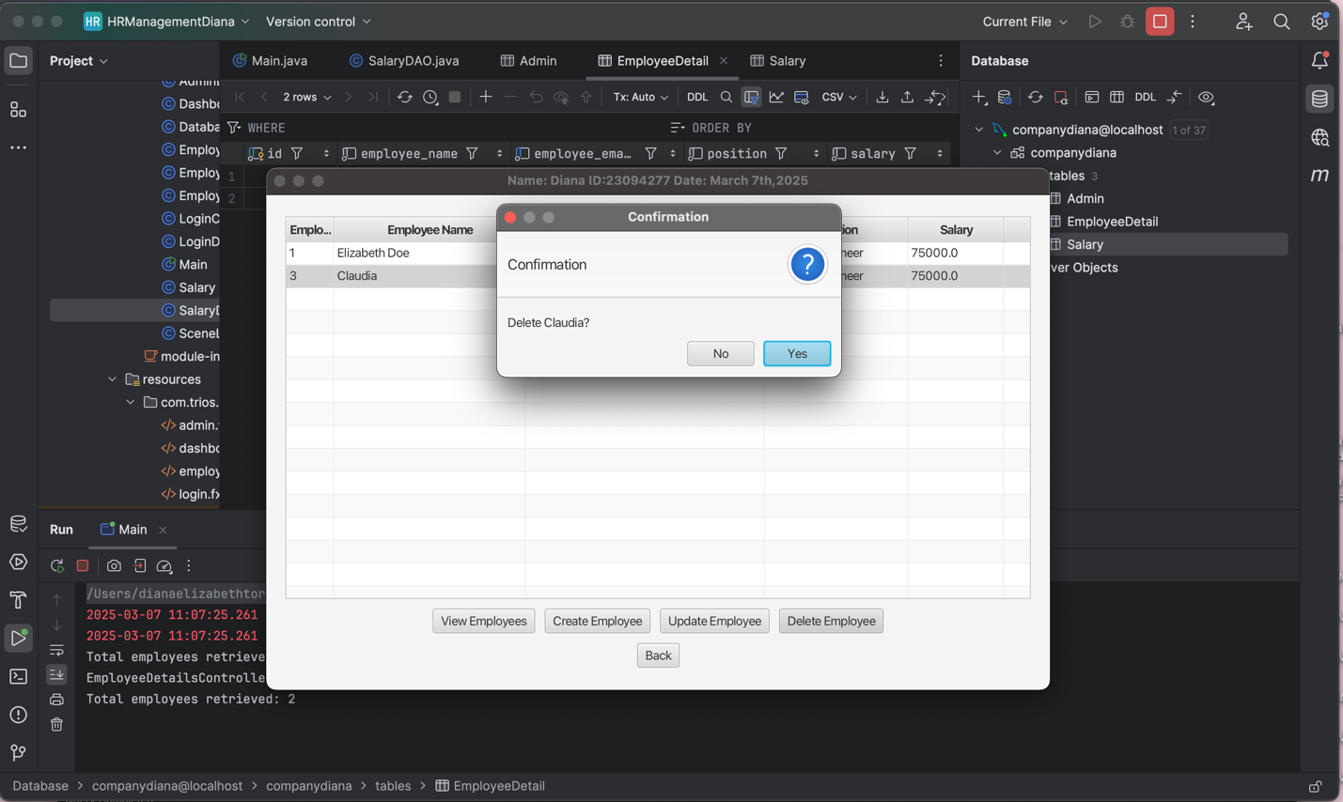

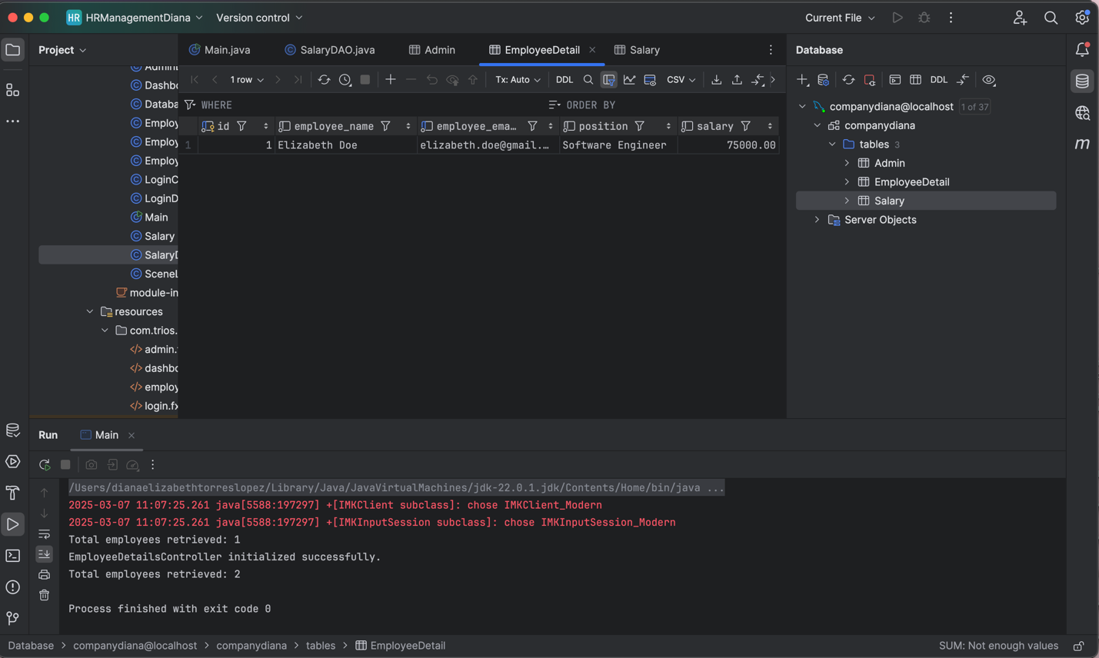

JUnit5 Test for SalaryDAO

1. Select the class, right click, then Show Actions, and Create test

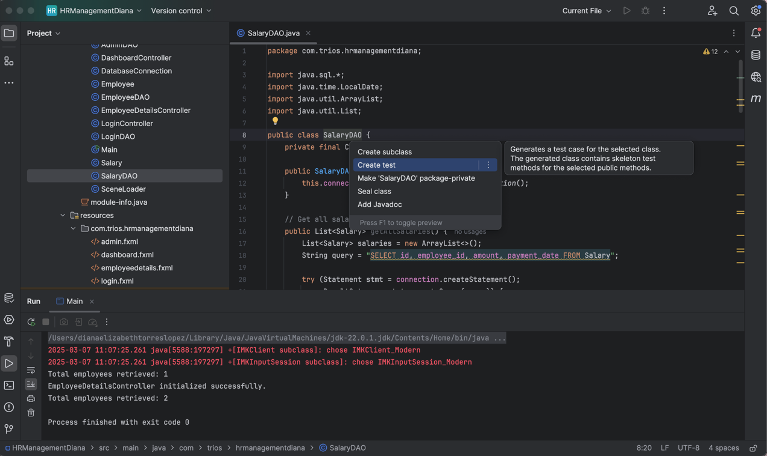

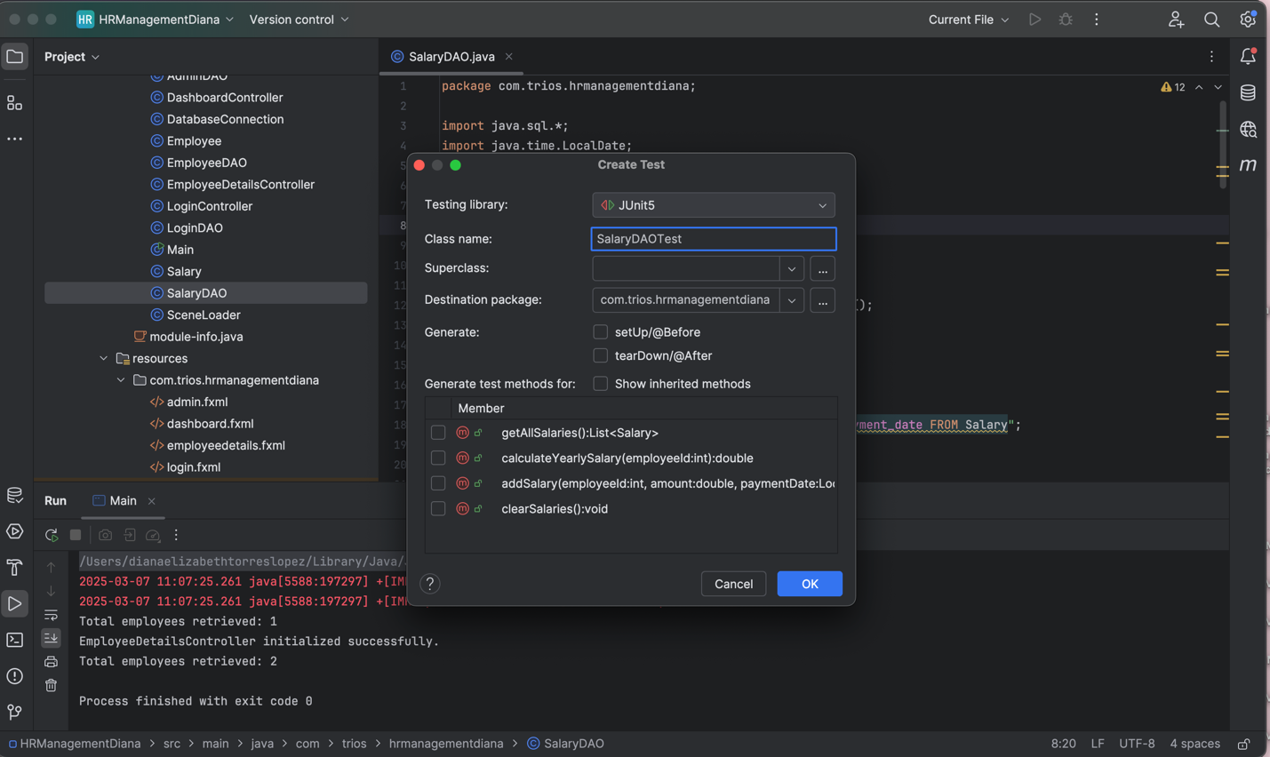

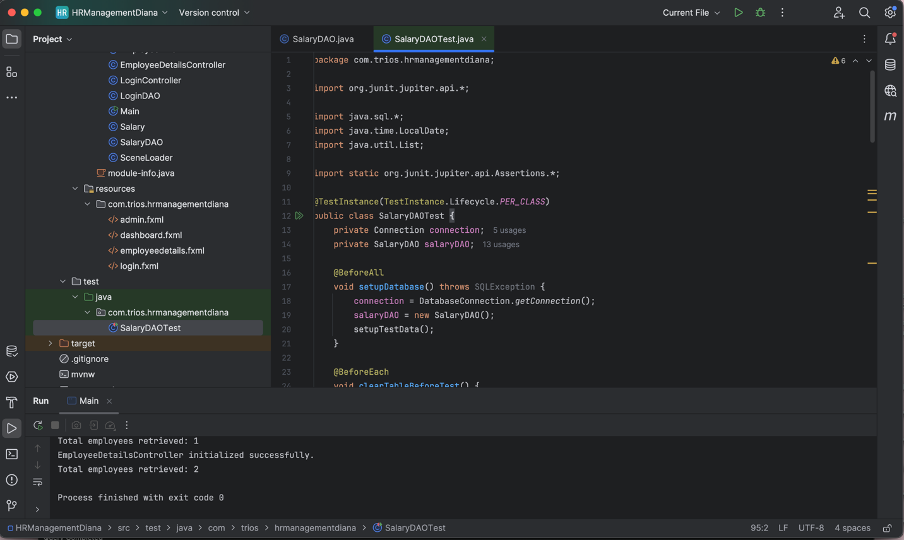

Java Code:

package com.trios.hrmanagementdiana;

import org.junit.jupiter.api.*;

import java.sql.*;

import java.time.LocalDate;

import java.util.List;

import static org.junit.jupiter.api.Assertions.*;

@TestInstance(TestInstance.Lifecycle.PER_CLASS)

public class SalaryDAOTest {

private Connection connection;

private SalaryDAO salaryDAO;

@BeforeAll

void setupDatabase() throws SQLException {

connection = DatabaseConnection.getConnection();

salaryDAO = new SalaryDAO();

setupTestData();

}

@BeforeEach

void clearTableBeforeTest() {

salaryDAO.clearSalaries();

setupTestData();

}

@AfterAll

void closeDatabase() throws SQLException {

if (connection != null) {

connection.close();

}

}

// Insert sample test data

private void setupTestData() {

try (Statement stmt = connection.createStatement()) {

stmt.execute("DELETE FROM Salary");

stmt.execute("DELETE FROM EmployeeDetail");

} catch (SQLException e) {

e.printStackTrace();

}

try (PreparedStatement stmt = connection.prepareStatement(

"INSERT INTO EmployeeDetail (id, employee_name, employee_email, position, salary) VALUES (?, ?, ?, ?, ?)")) {

stmt.setInt(1, 1);

stmt.setString(2, "Alice Johnson");

stmt.setString(3, "alice@example.com");

stmt.setString(4, "Software Engineer");

stmt.setDouble(5, 72000);

stmt.executeUpdate();

stmt.setInt(1, 2);

stmt.setString(2, "Bob Smith");

stmt.setString(3, "bob@example.com");

stmt.setString(4, "Project Manager");

stmt.setDouble(5, 90000);

stmt.executeUpdate();

} catch (SQLException e) {

e.printStackTrace();

}

// Insert Salary Records

salaryDAO.addSalary(1, 6000, LocalDate.of(2024, 1, 1));

salaryDAO.addSalary(1, 6000, LocalDate.of(2024, 2, 1));

salaryDAO.addSalary(1, 6000, LocalDate.of(2024, 3, 1));

salaryDAO.addSalary(2, 7500, LocalDate.of(2024, 1, 1));

salaryDAO.addSalary(2, 7500, LocalDate.of(2024, 2, 1));

salaryDAO.addSalary(2, 7500, LocalDate.of(2024, 3, 1));

}

@Test

void testGetAllSalaries() {

List<Salary> salaries = salaryDAO.getAllSalaries();

assertFalse(salaries.isEmpty(), "Salary records should not be empty");

}

@Test

void testCalculateYearlySalary() {

double yearlySalaryAlice = salaryDAO.calculateYearlySalary(1);

assertEquals(18000, yearlySalaryAlice, "Yearly salary for Alice should be 18,000");

double yearlySalaryBob = salaryDAO.calculateYearlySalary(2);

assertEquals(22500, yearlySalaryBob, "Yearly salary for Bob should be 22,500");

}

@Test

void testAddSalary() {

salaryDAO.addSalary(1, 7000, LocalDate.of(2024, 4, 1));

double updatedYearlySalary = salaryDAO.calculateYearlySalary(1);

assertEquals(25000, updatedYearlySalary, "Updated yearly salary for Alice should be 25,000");

}

}

We run the Test to check if it passes.

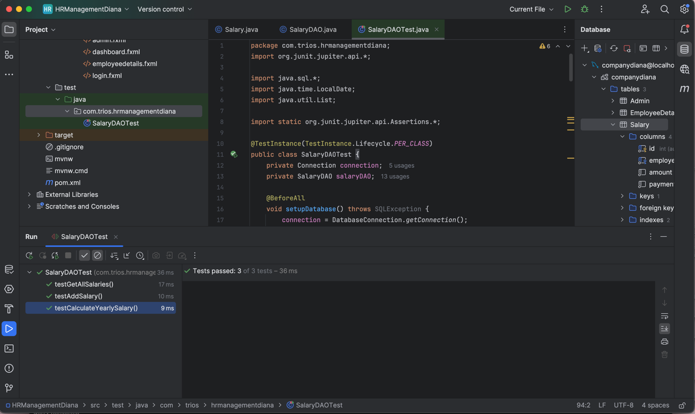

GitHub Link:

<https://github.com/dianadeliz/CSD214Lab3>